REALISASI ANGGARAN

# KONTROL PERUBAHAN BLUEPRINT

|  |  |  |
| --- | --- | --- |
| **Document Version** | **Change Date** | **Description** |
|  |  |  |
|  |  |  |
|  |  |  |

# HALAMAN PENGESAHAN

DAFTAR ISI

KONTROL PERUBAHAN BLUEPRINT 2

HALAMAN PENGESAHAN 3

1. Background 5

2. Goals 5

3. Scope of Work 5

3.1. Scope 5

3.2. Sitemap/Mind Map 5

4. Desain System 6

4.1. Use Case 6

4.2. Flow Process Business & System 6

4.2.1. Flow Process Login 7

4.2.2. Flow Process Track Your Co 8

4.2.3. Flow Process Experience 10

4.2.4. Flow Process Tools 12

4.2.5. Flow Process Equipment 14

4.2.6. Flow Process My Profile 14

4.3. Application’s Mockup 20

4.3.1. Module Login 20

4.3.2. Module Track Your Co 20

4.3.3. Module Experience 20  
4.3.4. Module Tools 20  
4.3.5. Module Equipment 20  
4.3.6. Module Profile 20

4.4. Desain Database 20

4.5. Role Matrix 20

Lampiran 21

## Background

Tingginya pengajuan dan permintaan persetujuan realisasi anggaran dari user, baik untuk investasi maupun other operating expenses membuat Dinas TA membutuhkan tools untuk mempermudah proses control, monitoring dan mempercepat proses realisasi anggaran.

## Goals

* Sebagai alat control dan monitoring untuk pengajuan dan realisasinya, baik investasi maupun other operating expenses
* Meminimalisir adanya pengajuan yang terlewat karena proses pengajuan yang selama ini manual melalui email
* Memudahkan user untuk mengetahui status pengajuan, dan sisa anggaran yang tersedia
* Mempercepat proses realisasi anggaran
* Mengetahui urgensi setiap pengajuan sehingga dapat menentukan pengajuan mana yang perlu di proses terlebih dahulu untuk menyesuikan kecukupan budget yang tersedia
* Memudahkan tracking status dan update atas IO dan PO yang sudah diterima/GR dan payment

## Scope of Work

### Scope

|  |  |
| --- | --- |
| **Page** | **Description** |
| Dashboard | Page to monitor, create, edit and approval request |
| Need Approval | Page to monitor, edit and approval request |
| Reallocation Budget | Page to monitor, create, edit and approval reallocation budget |
| Report | Page to monitor report request |
| Master Data | Page to monitor and upload master data |

### Sitemap/Mind Map

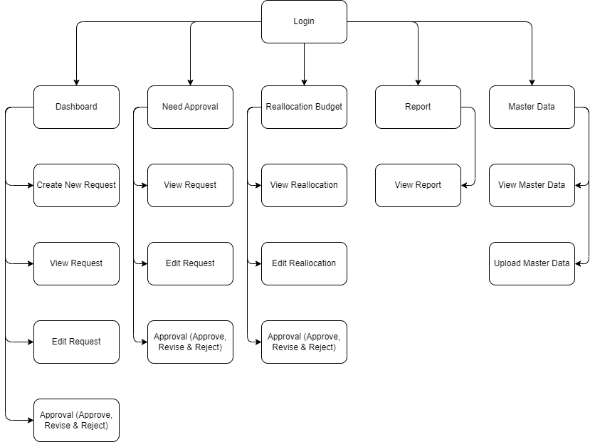

Image 1 Site Map

## Desain System

### Use Case

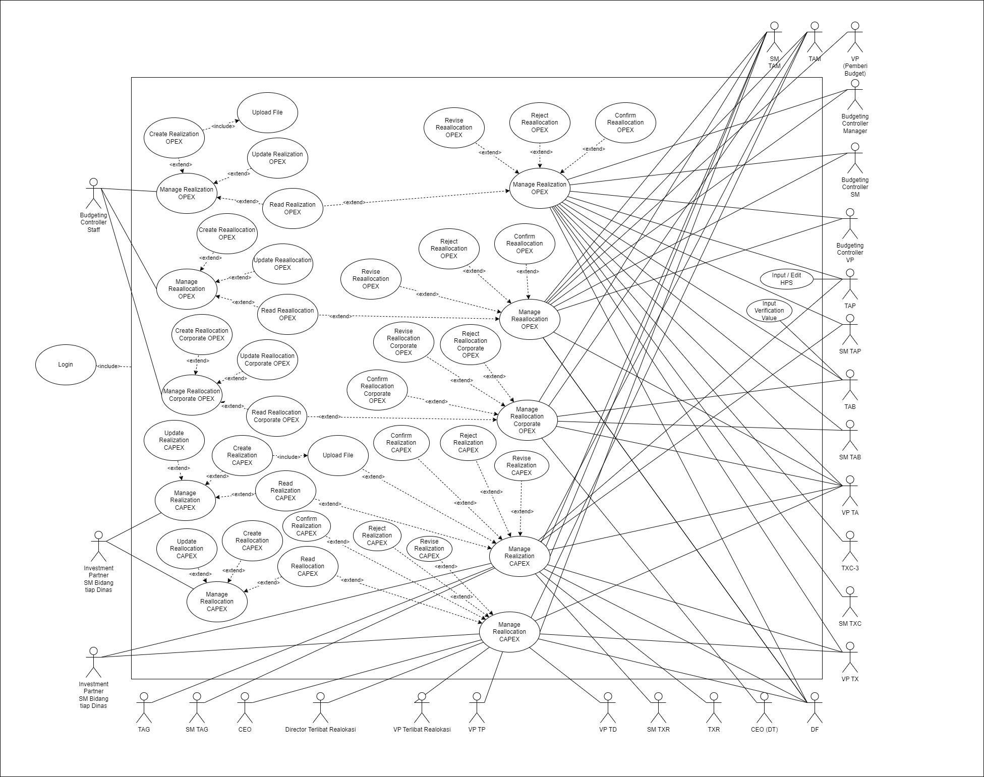

Image 2Use Case Diagram

### Flow Process Business

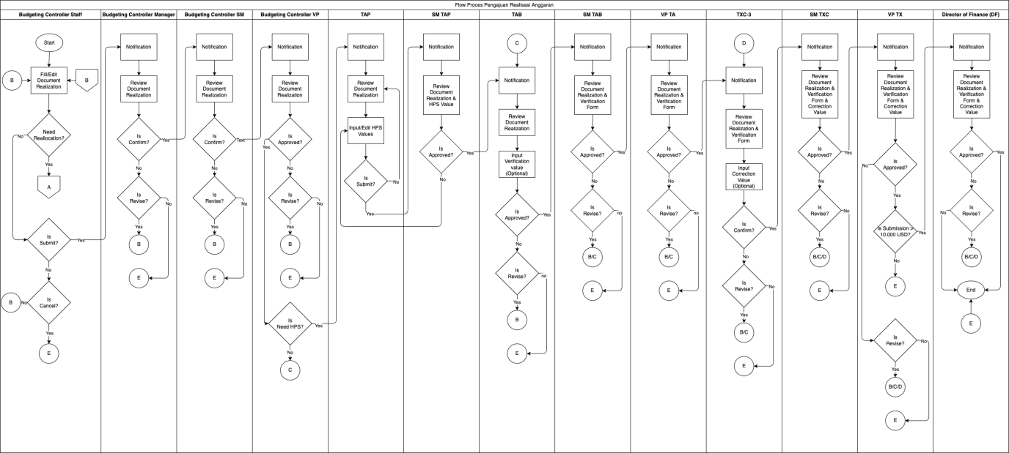

Image 3 Flow Process Realisasi Anggaran OPEX

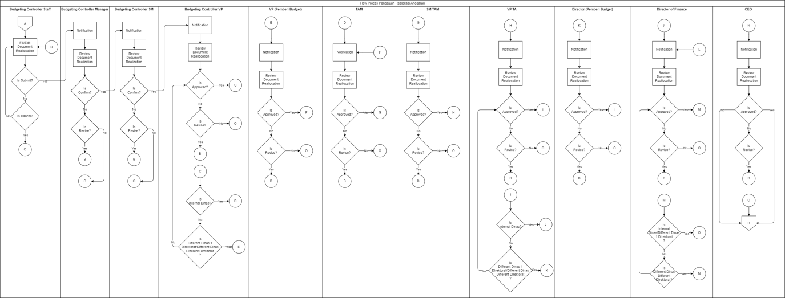

Image 4 Flow Process Realokasi Anggaran OPEX

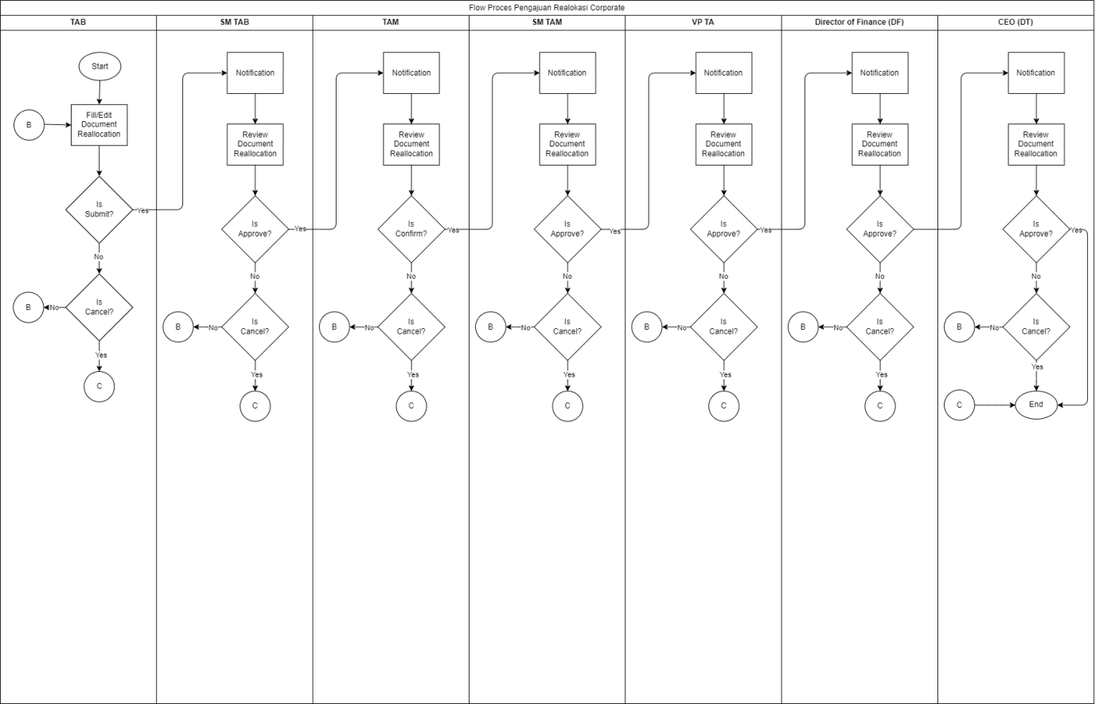

Image 5 Flow Process Realokasi Corporate

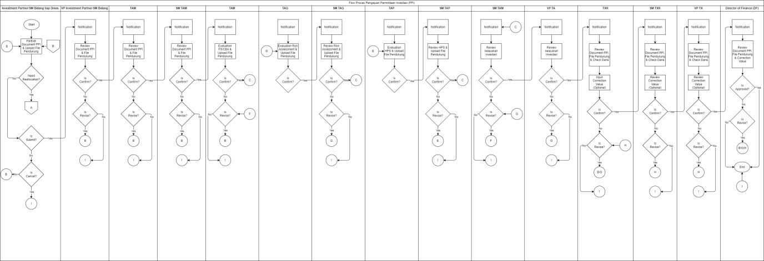

Image 6 Flow Process Request PPI CAPEX

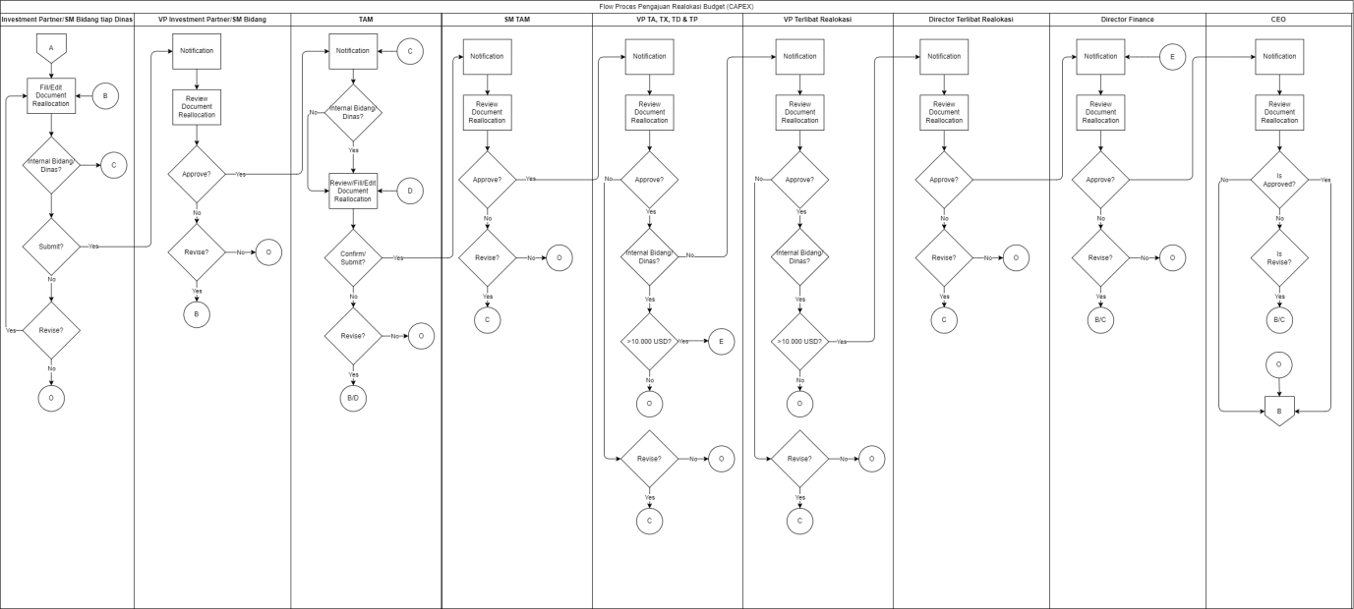

Image 7 Flow Process Realokasi Budget CAPEX

### Application’s Mockup & Flow System

#### Login

#### Flow Process Login

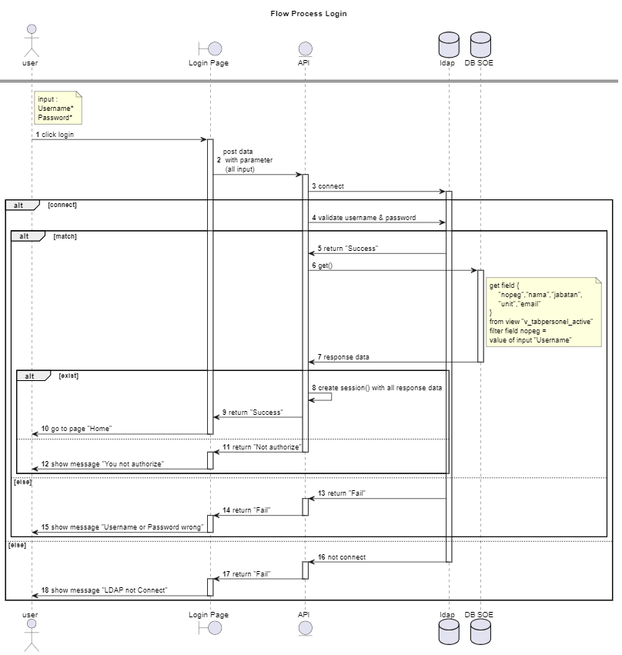

#### Master Data Kurs USD

#### Application’s Mockup Master Data Kurs USD

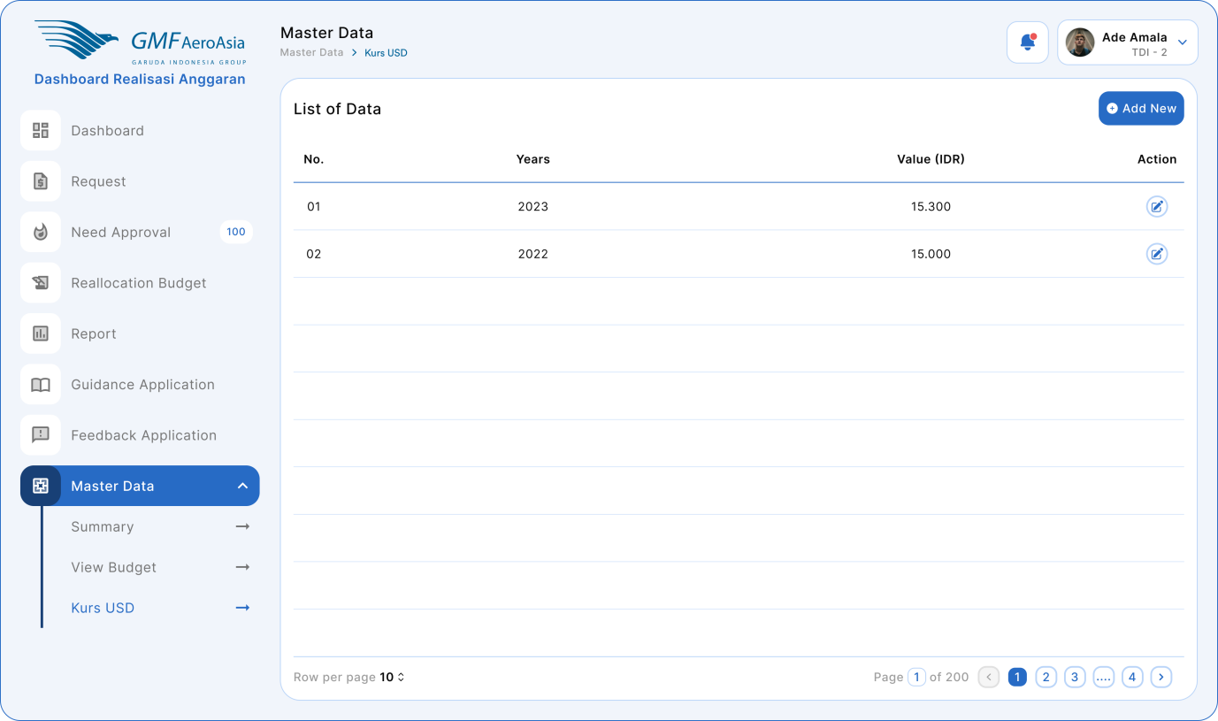

Figure 1 Master Data Kurs USD

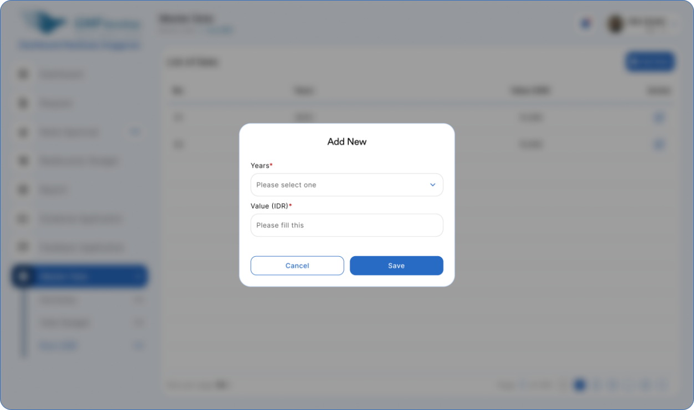

Figure 2 Add Master Data Kurs USD

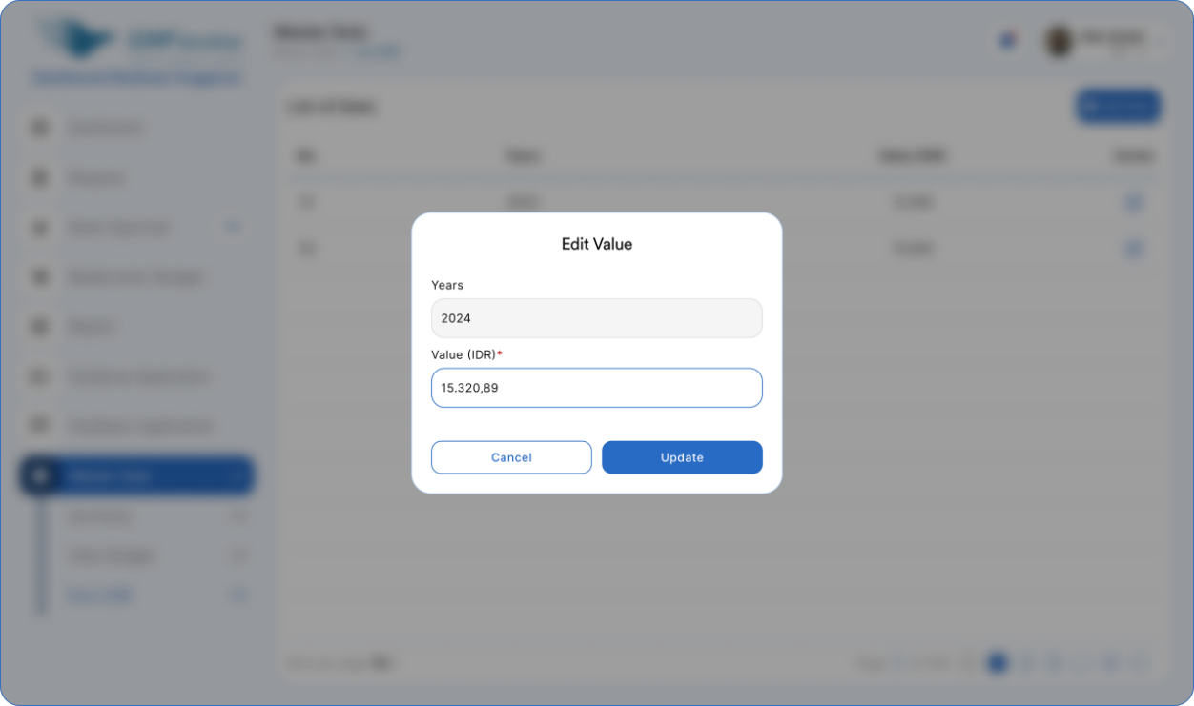

Figure 3 Update Master Data Kurs USD

#### Flow Process Master Data Kurs USD

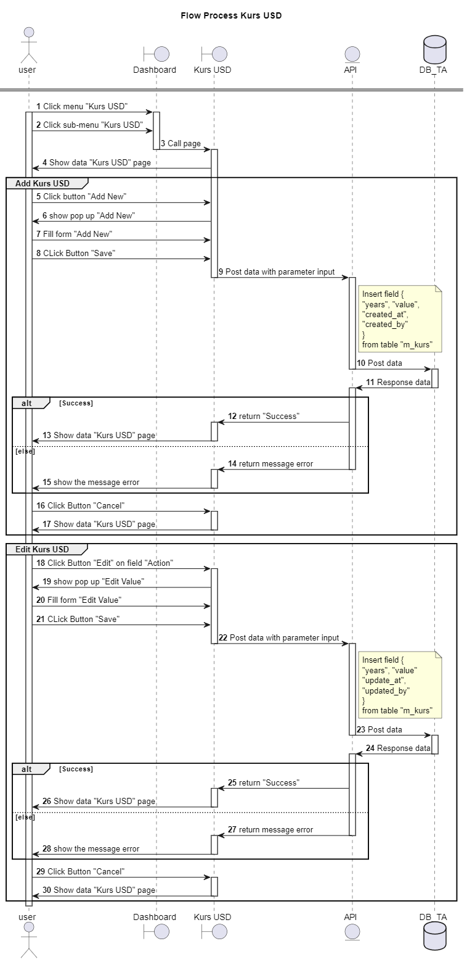

#### Request Realization & Reallocation OPEX

#### Application’s Mockup Request Realization & Reallocation OPEX

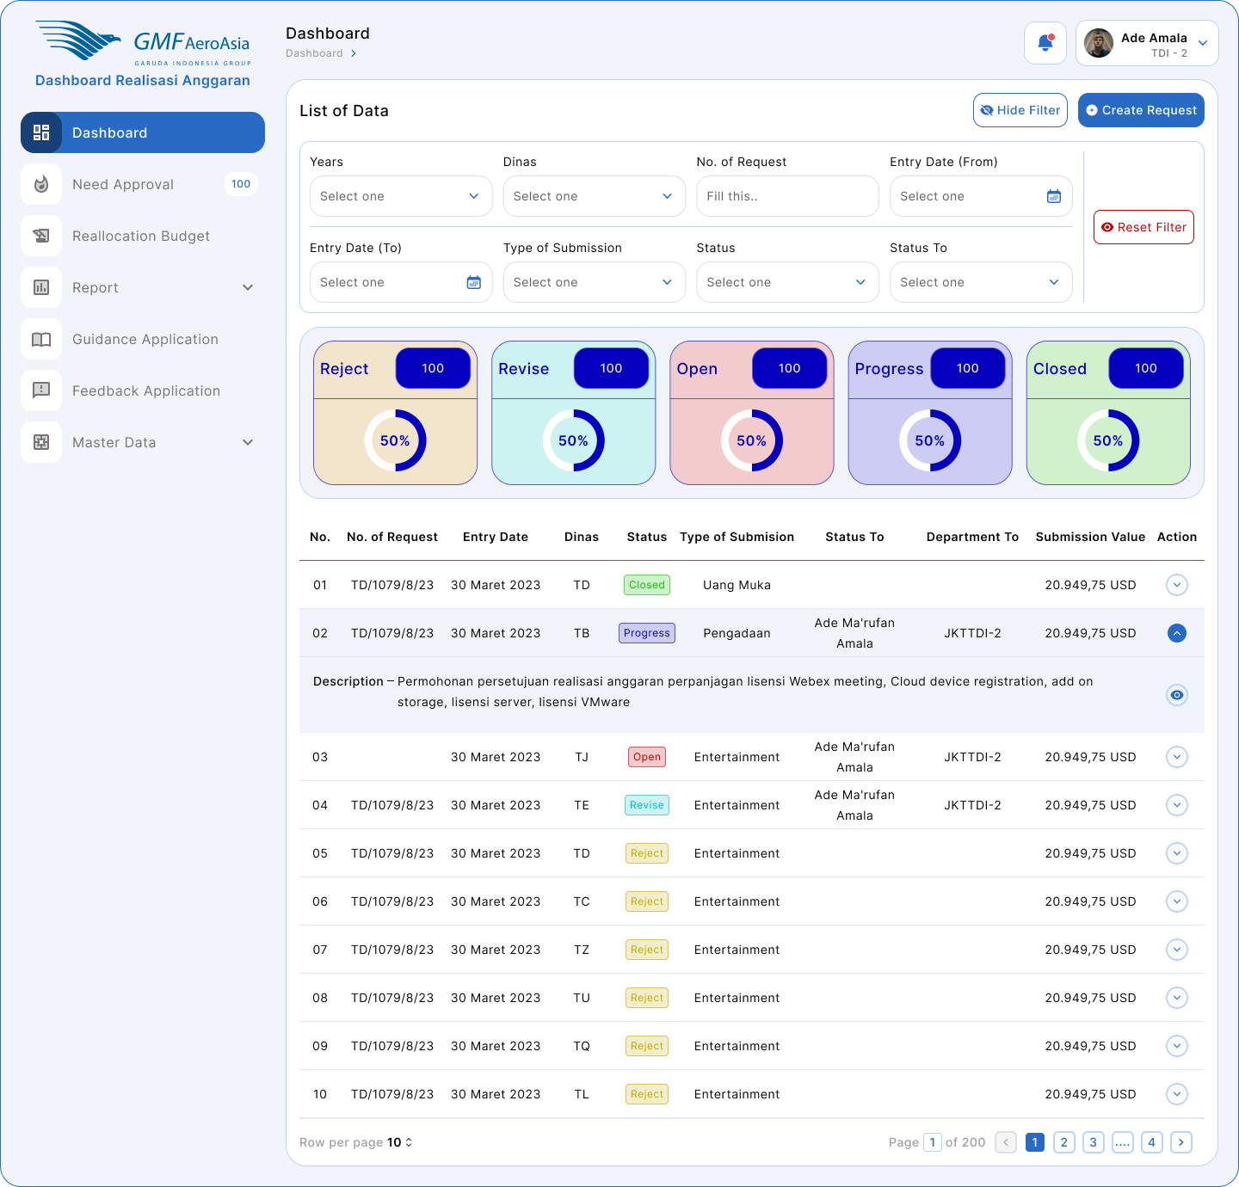

Figure 4 Application Mockup Dashboard Realisasi Anggaran

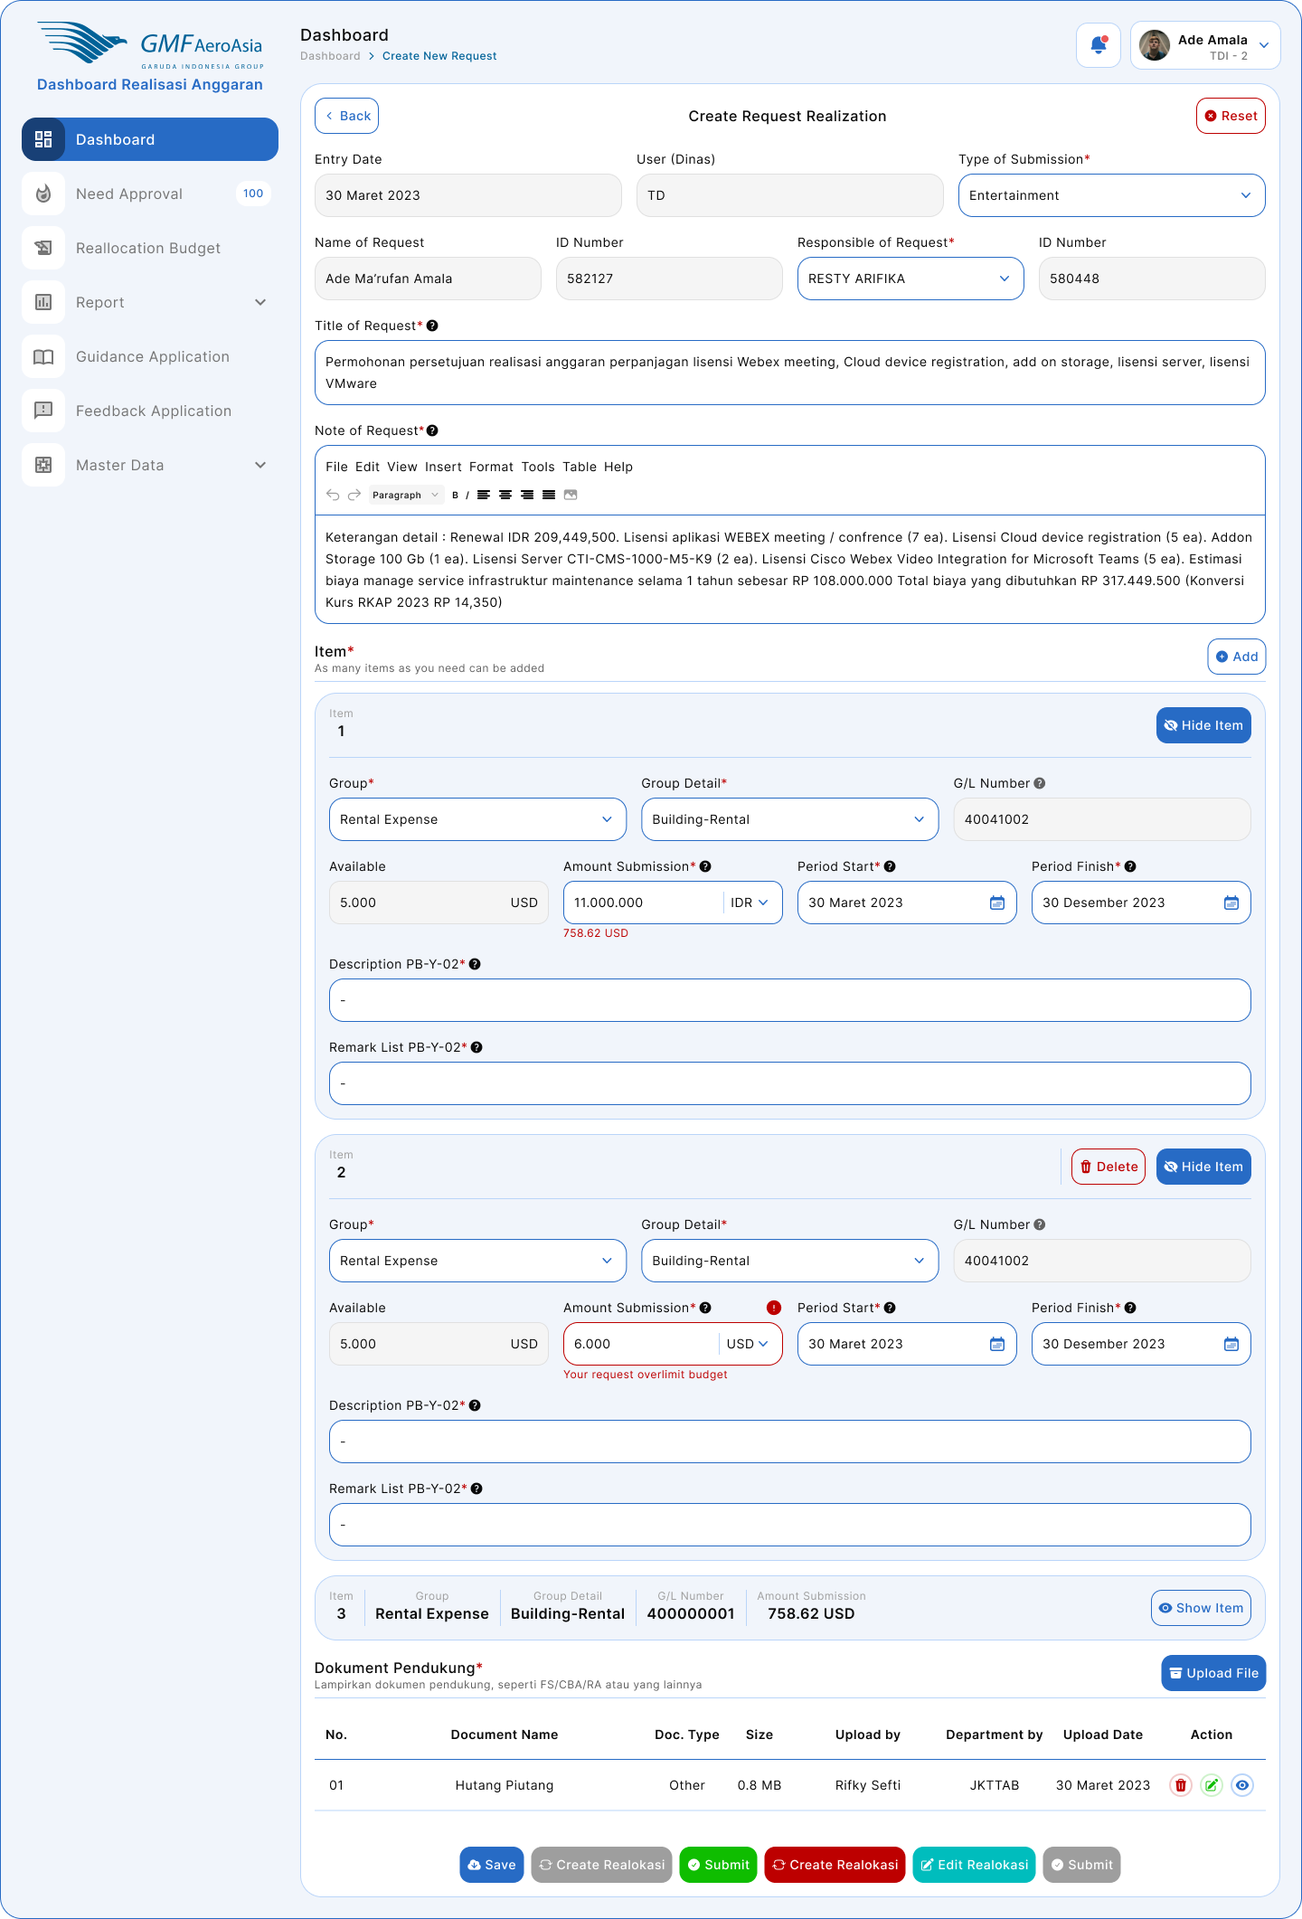

Figure 5 Application Mockup Dashboard Realisasi Anggaran

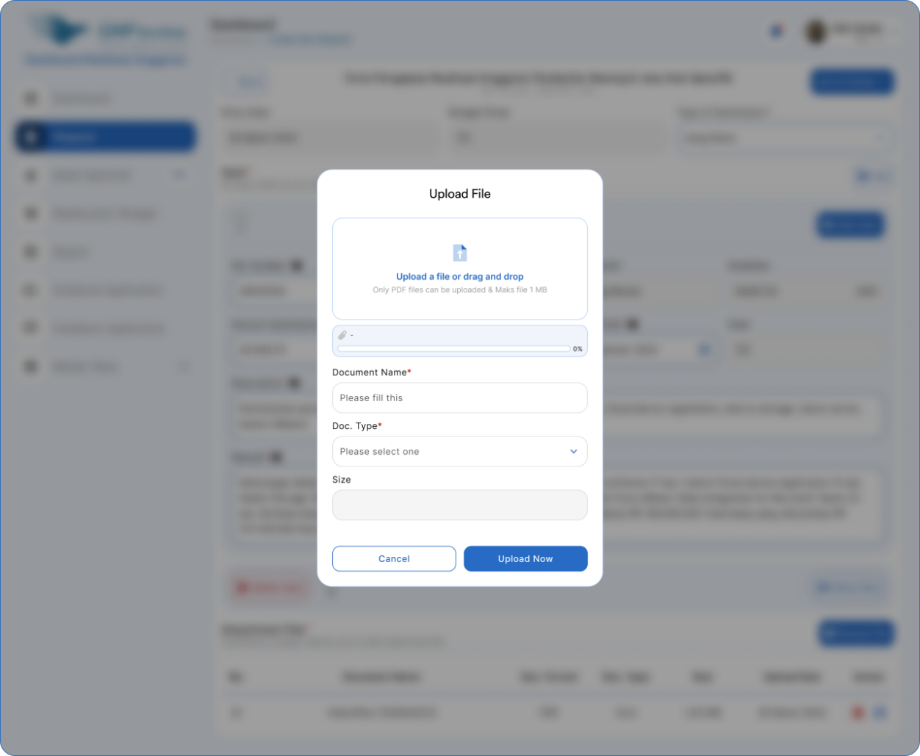

Figure 6 Application Mockup Upload File Realisasi Anggaran

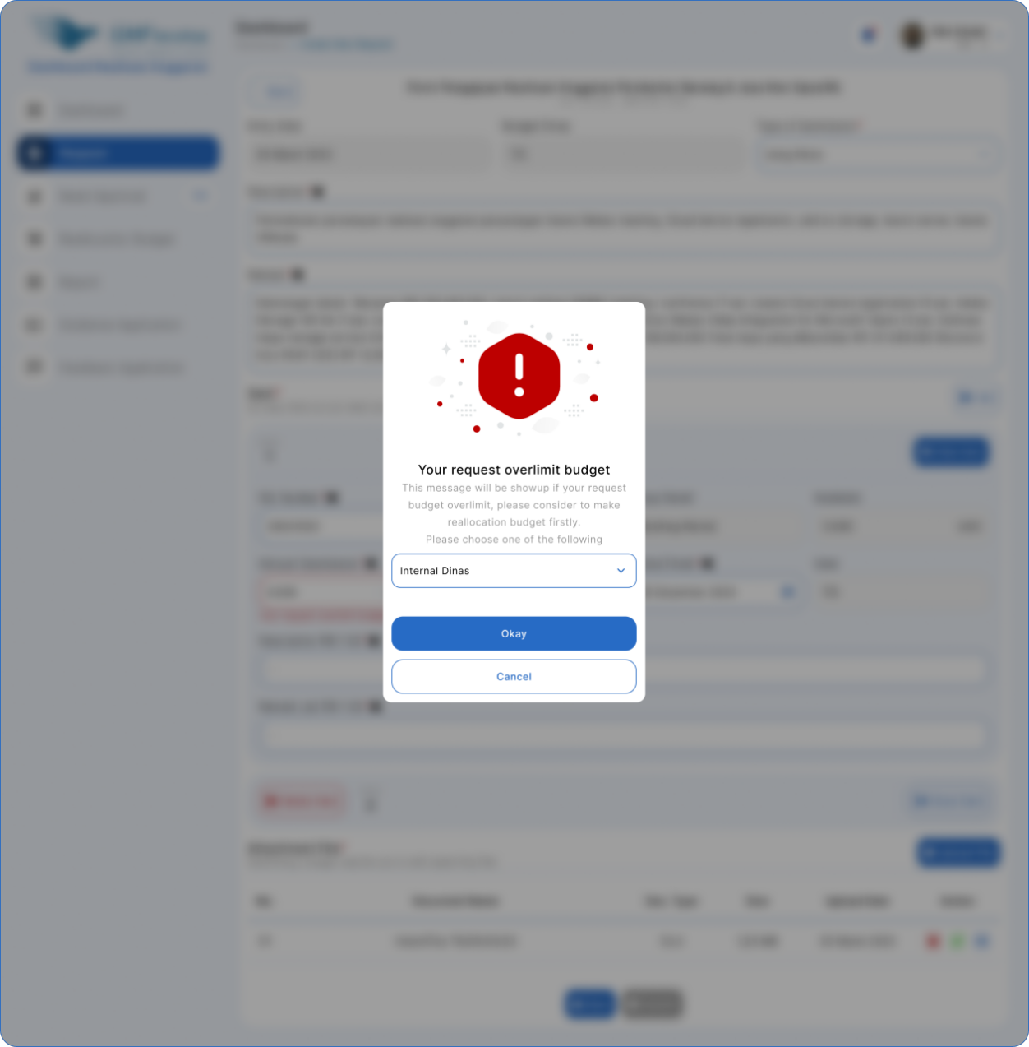

Figure 7 Application Mockup Overlimit Budget Realisasi Anggaran

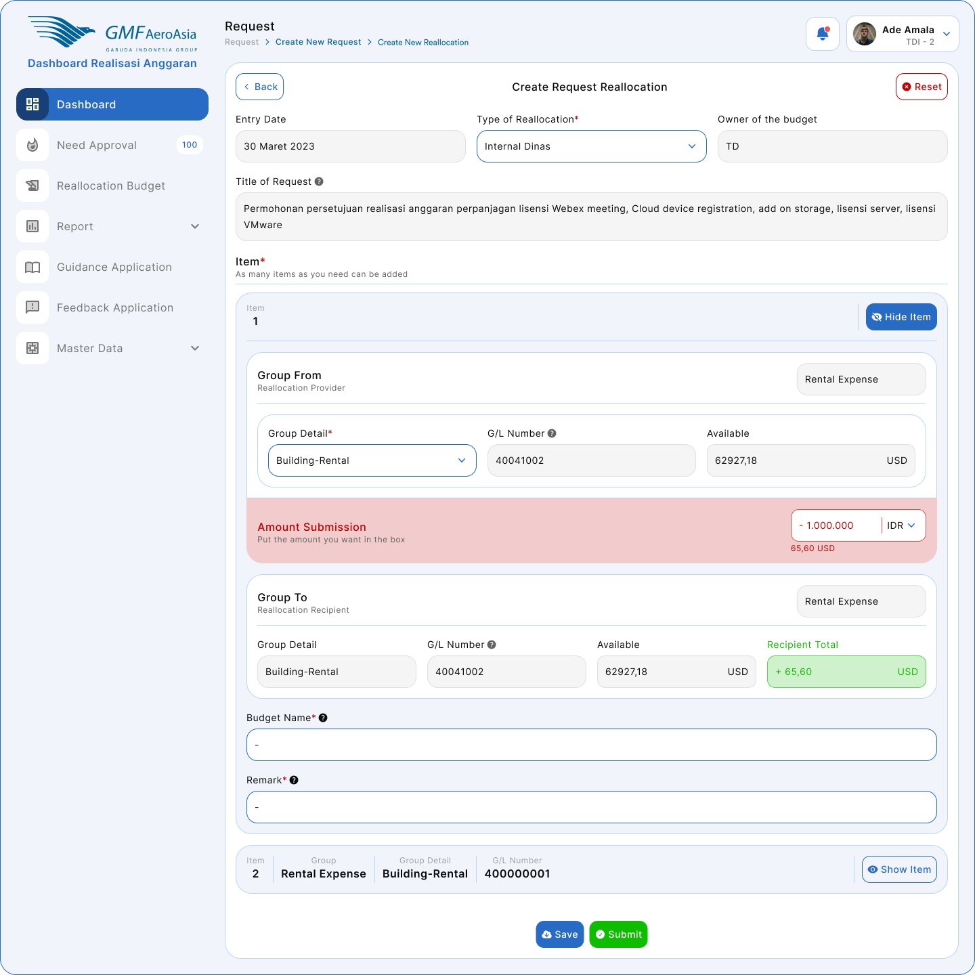

Figure 8 Application Mockup Create Request Reallocation OPEX

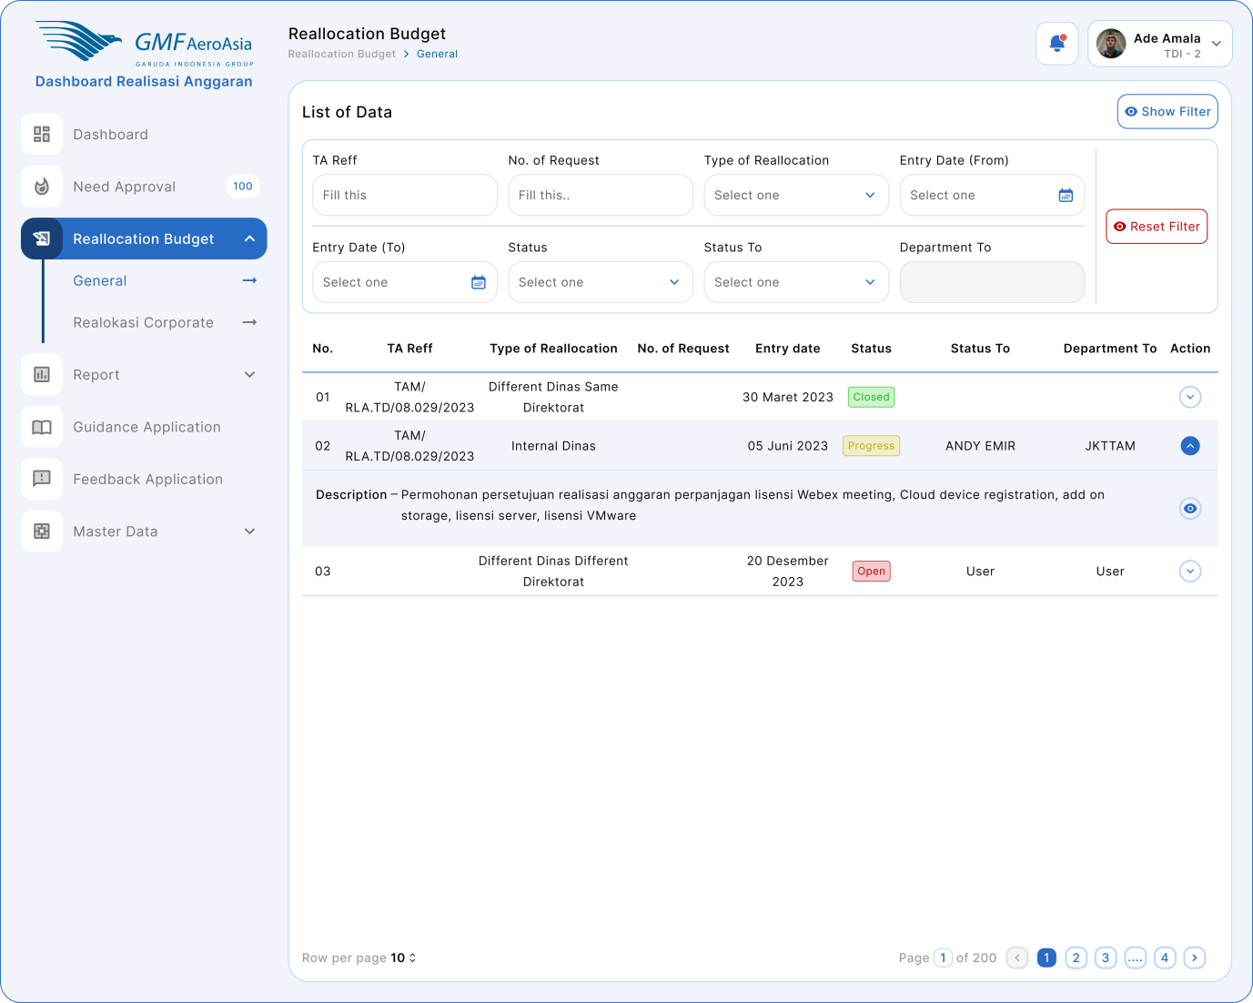

Figure 9 Reallocation Budget General

#### Application’s Mockup Request Realization & Reallocation OPEX

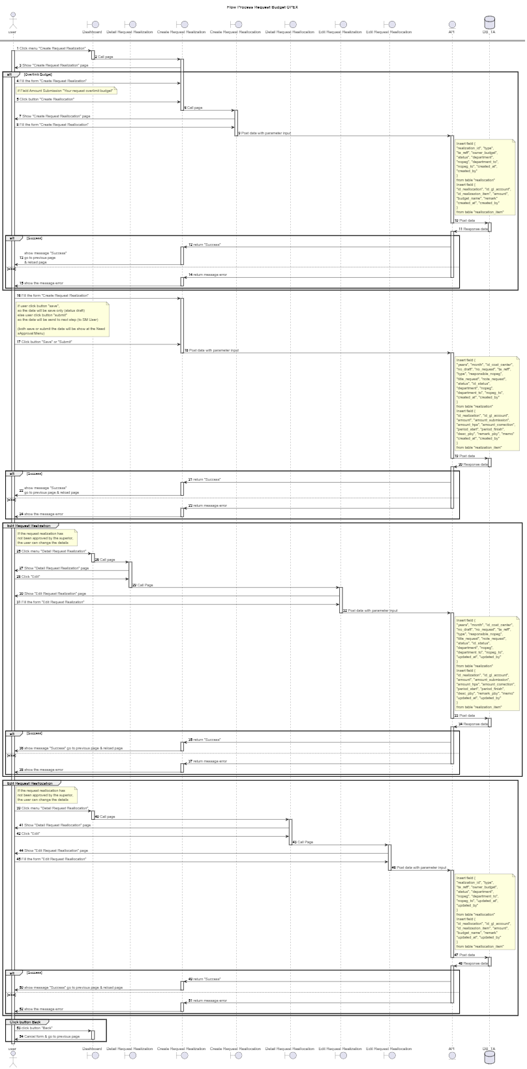

#### Reallocation Corporate OPEX

#### Application Mockup Reallocation Corporate OPEX

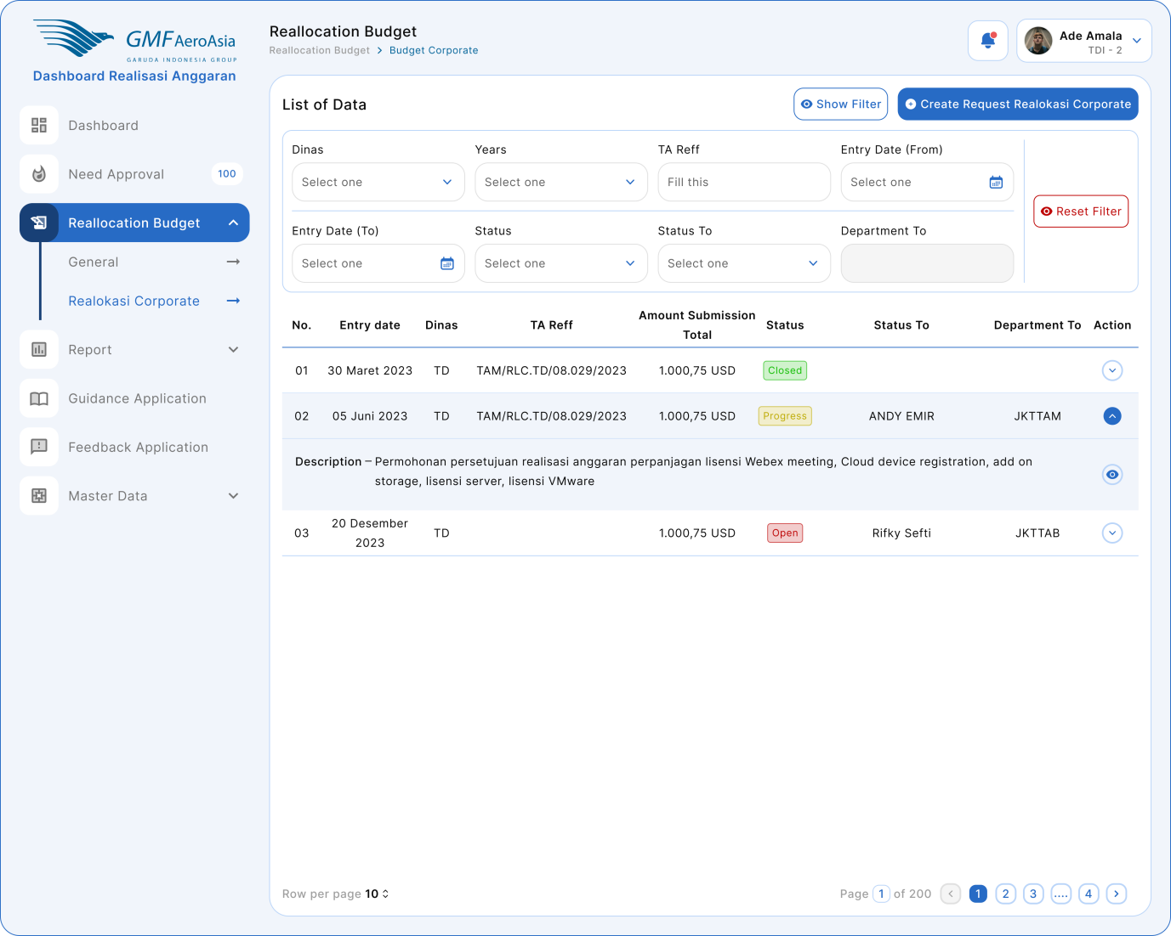

Figure 10 Reallocation Corporate OPEX

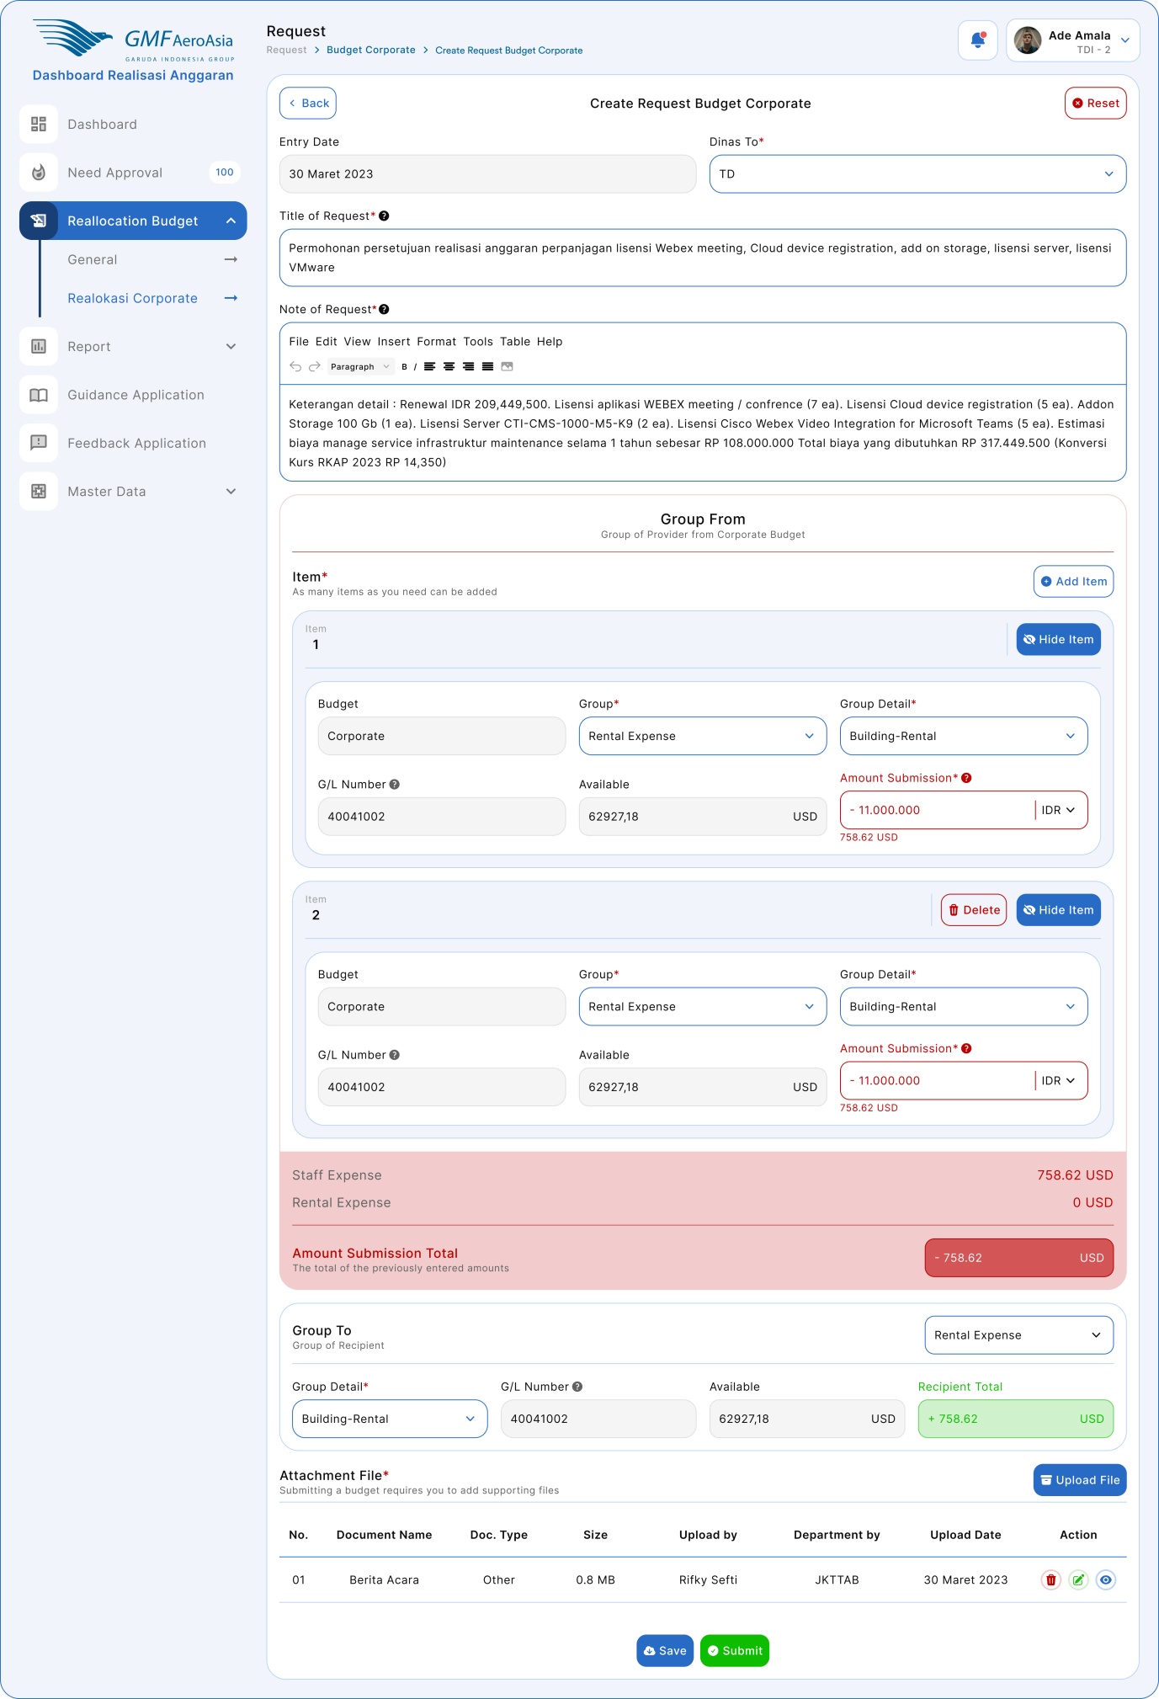

Figure 11 Create Request Reallocation Corporate OPEX

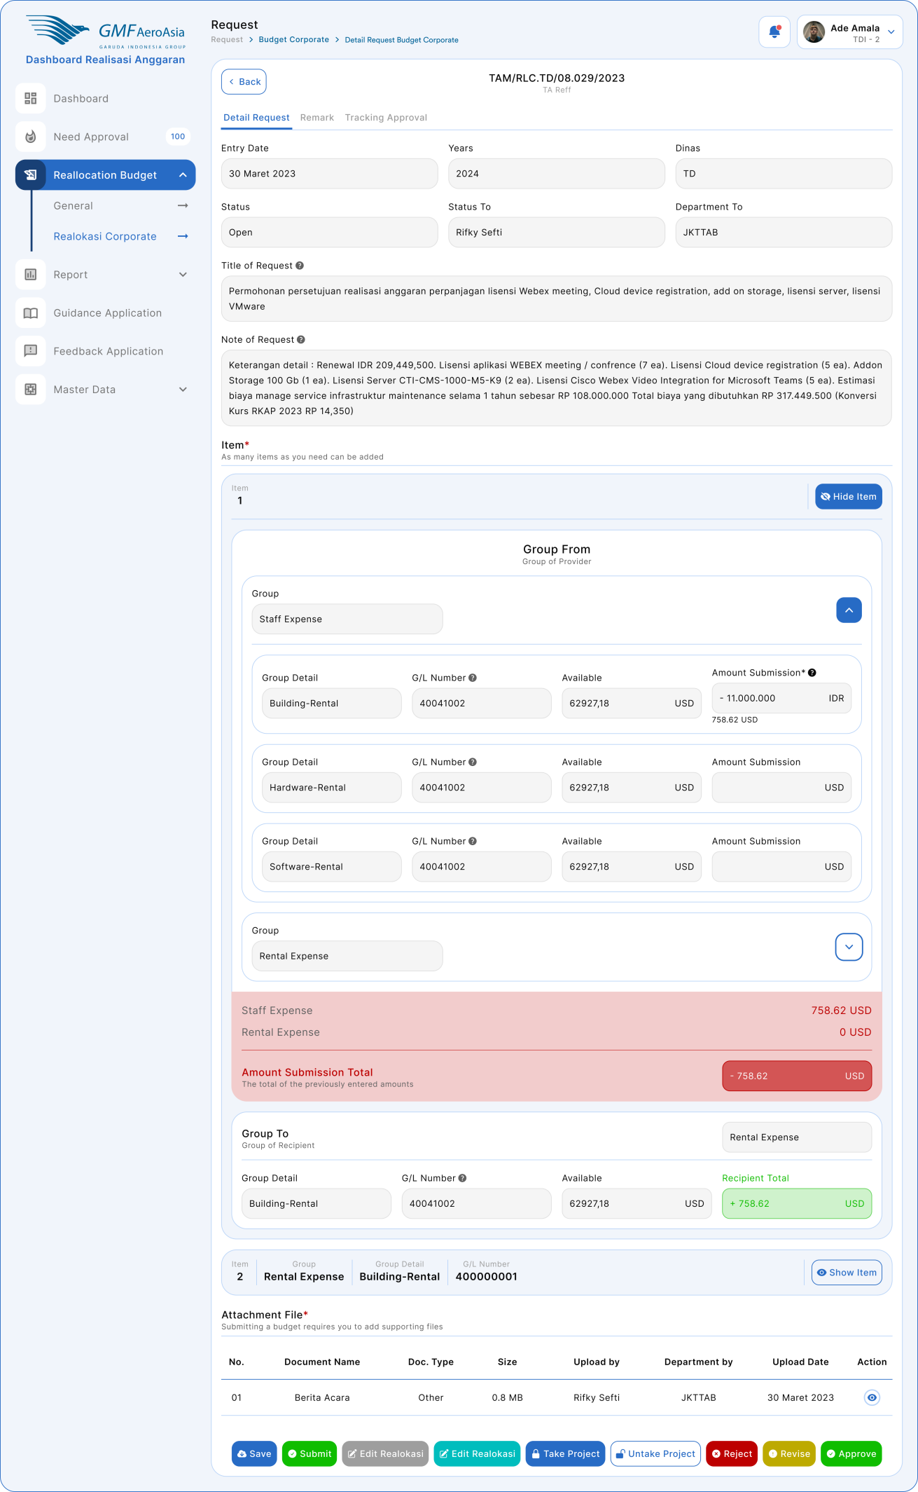

Figure 12 Detail Reallocation Corporate

#### Flow Process Reallocation Corporate OPEX

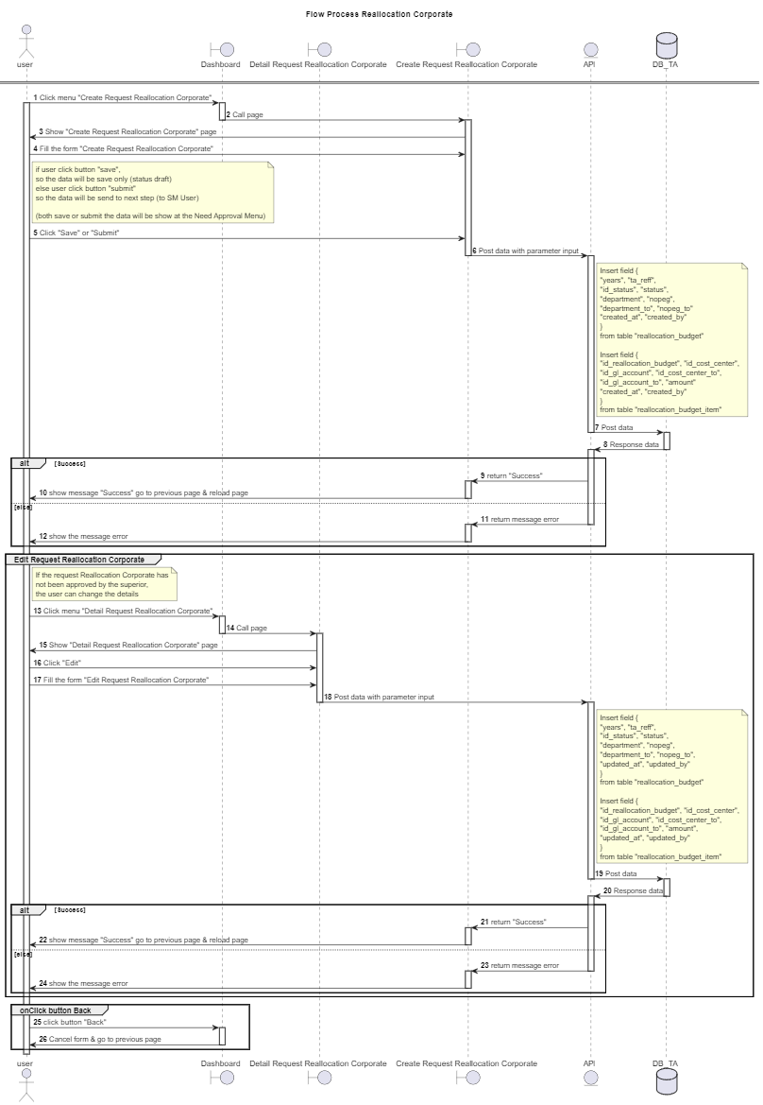

#### Master Data Summary

#### Application Mockup Master Data Summary

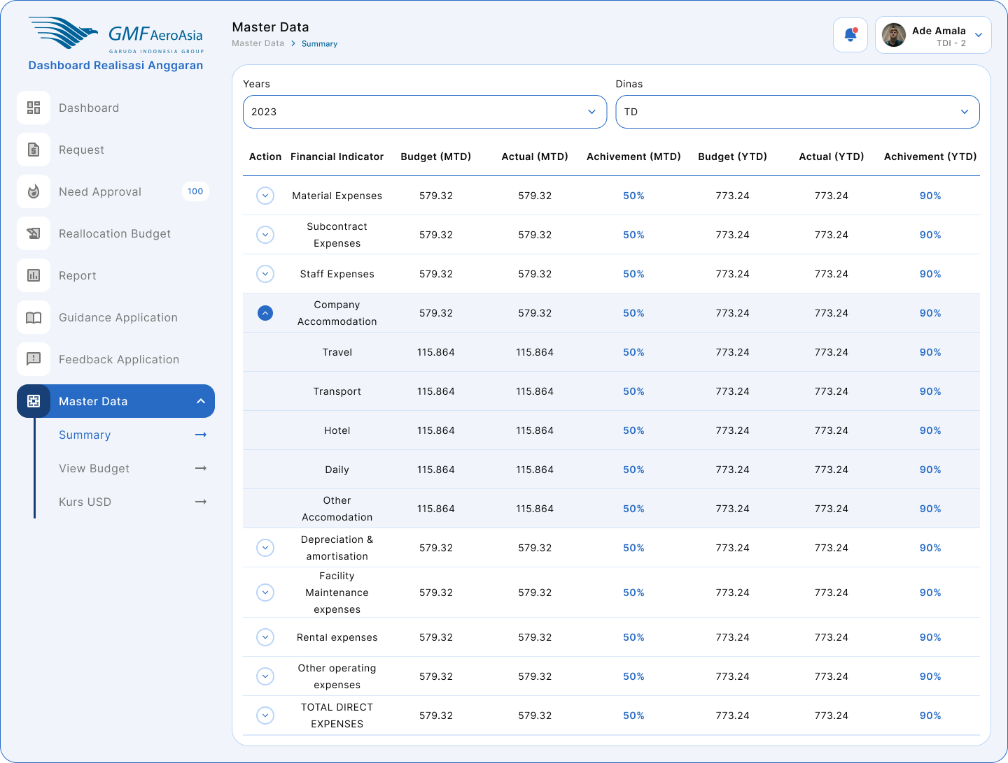

Figure 13 Master Data Summary

#### Flow Process Master Data Summary

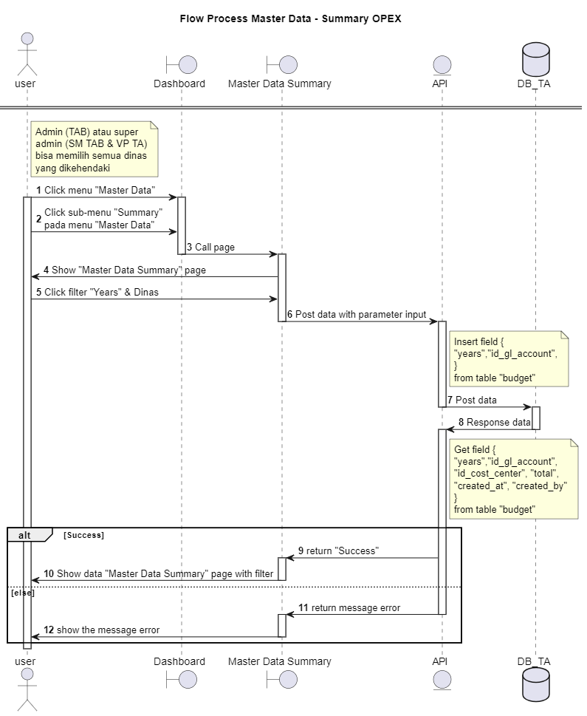

#### Upload RKAP OPEX

#### Application Mockup Upload RKAP OPEX

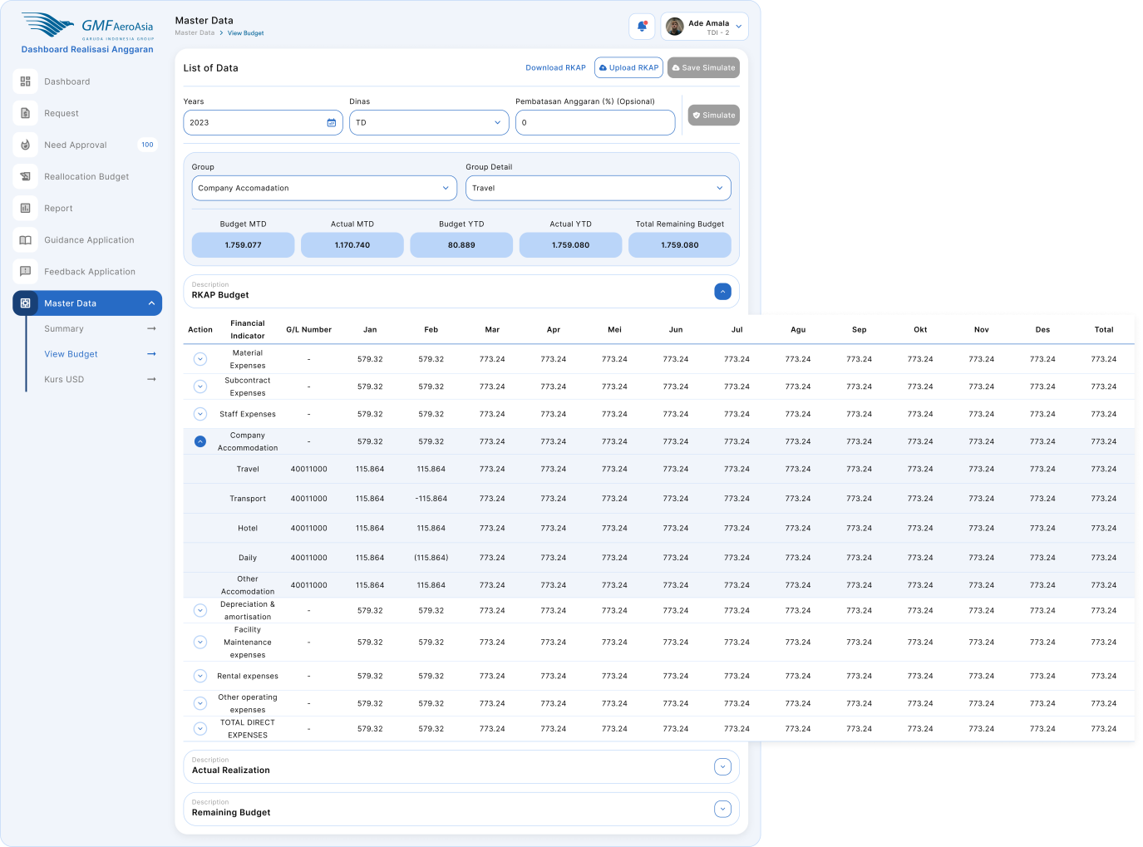

Figure 14 Master View Budget

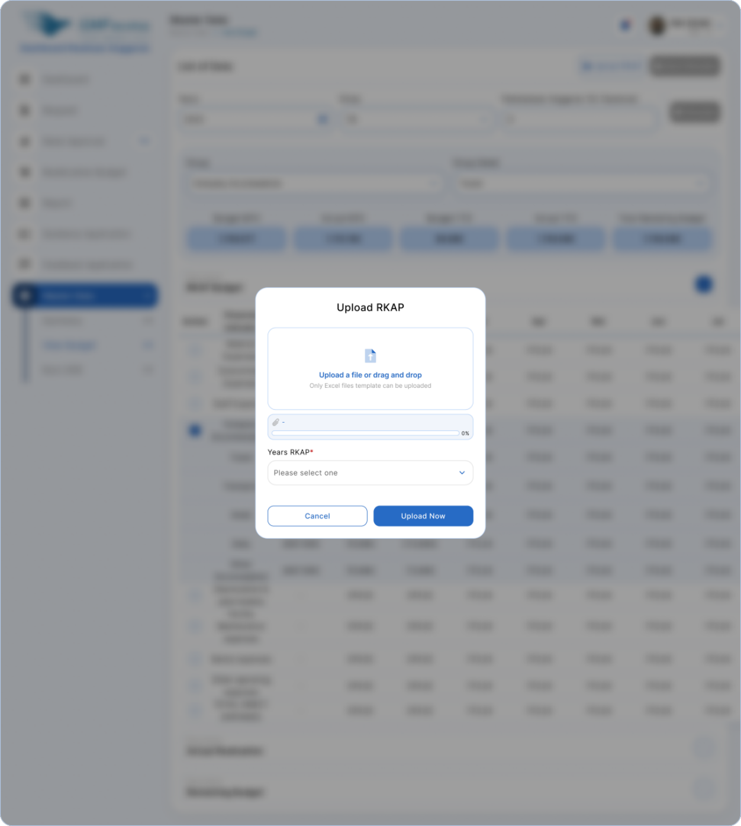

Figure 15 Upload RKAP

#### Flow Process Upload RKAP OPEX

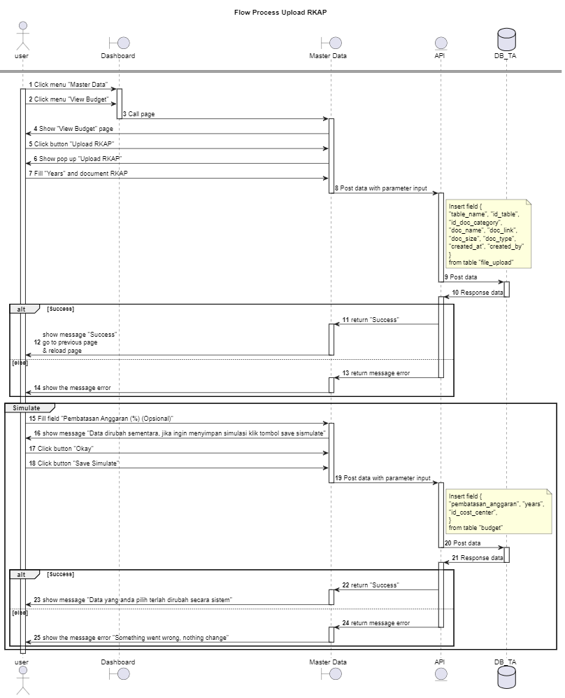

Figure 16 Upload RKAP OPEX

#### Report OPEX

#### Application Mockup Report OPEXSummary

Figure 17 Report Summary

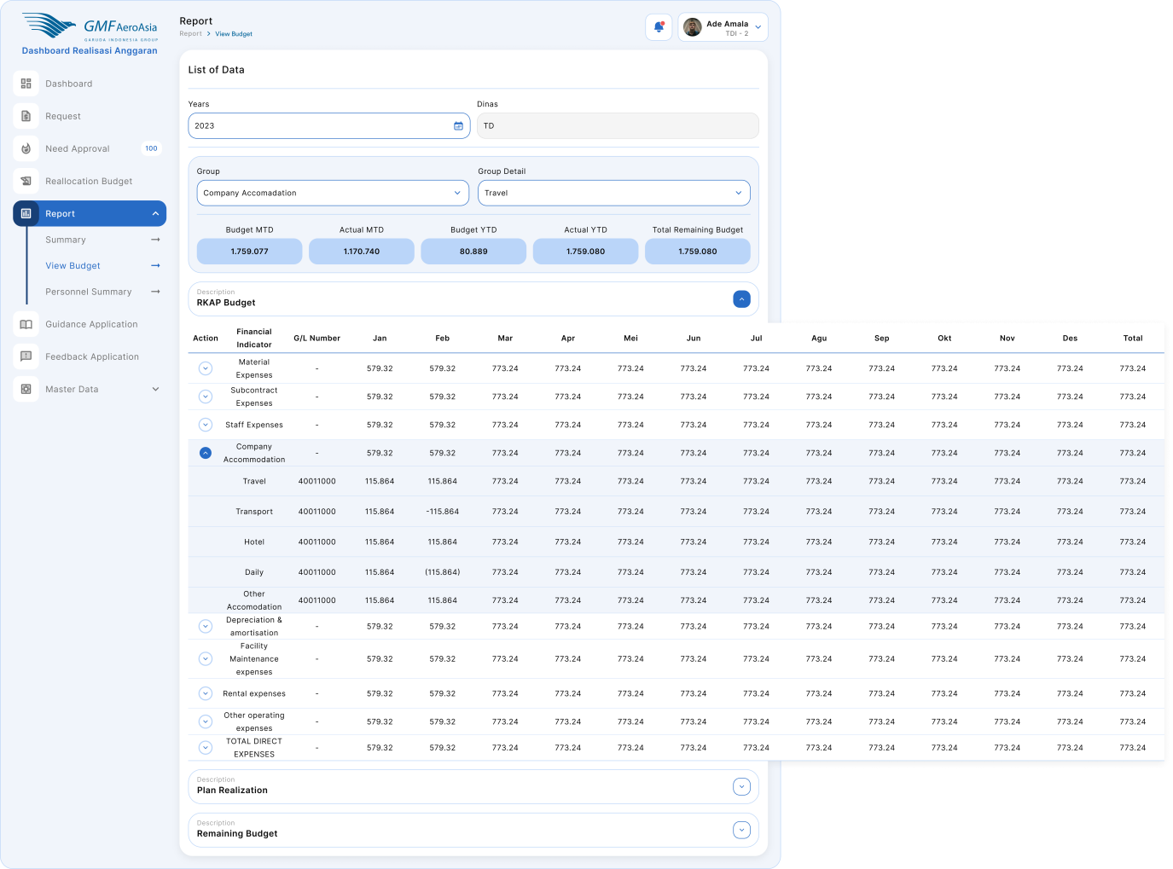

Figure 18 Report Budget

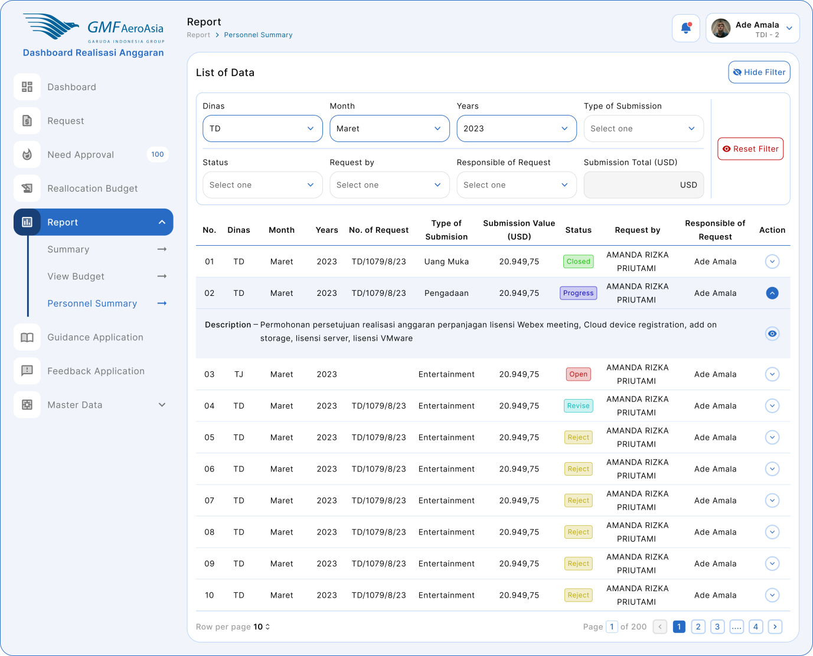

Figure 19 Report Personnel Summary

#### Flow Process Report OPEX

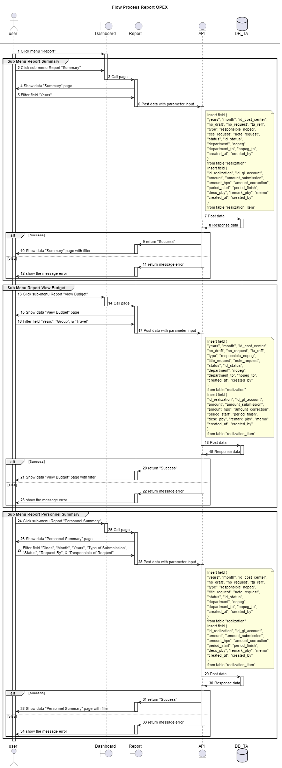

Figure 20 Report OPEX

#### Upload RKAP CAPEX

#### Application Mockup Upload RKAP CAPEX

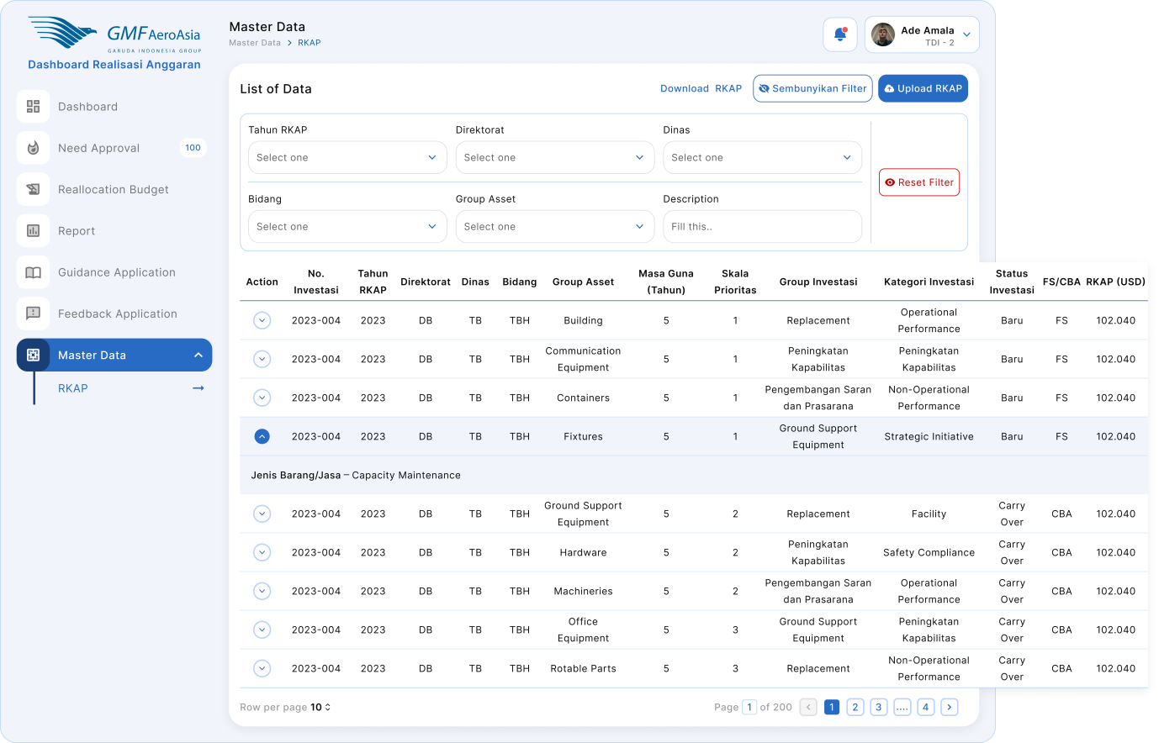

Figure 21 Master Data CAPEX

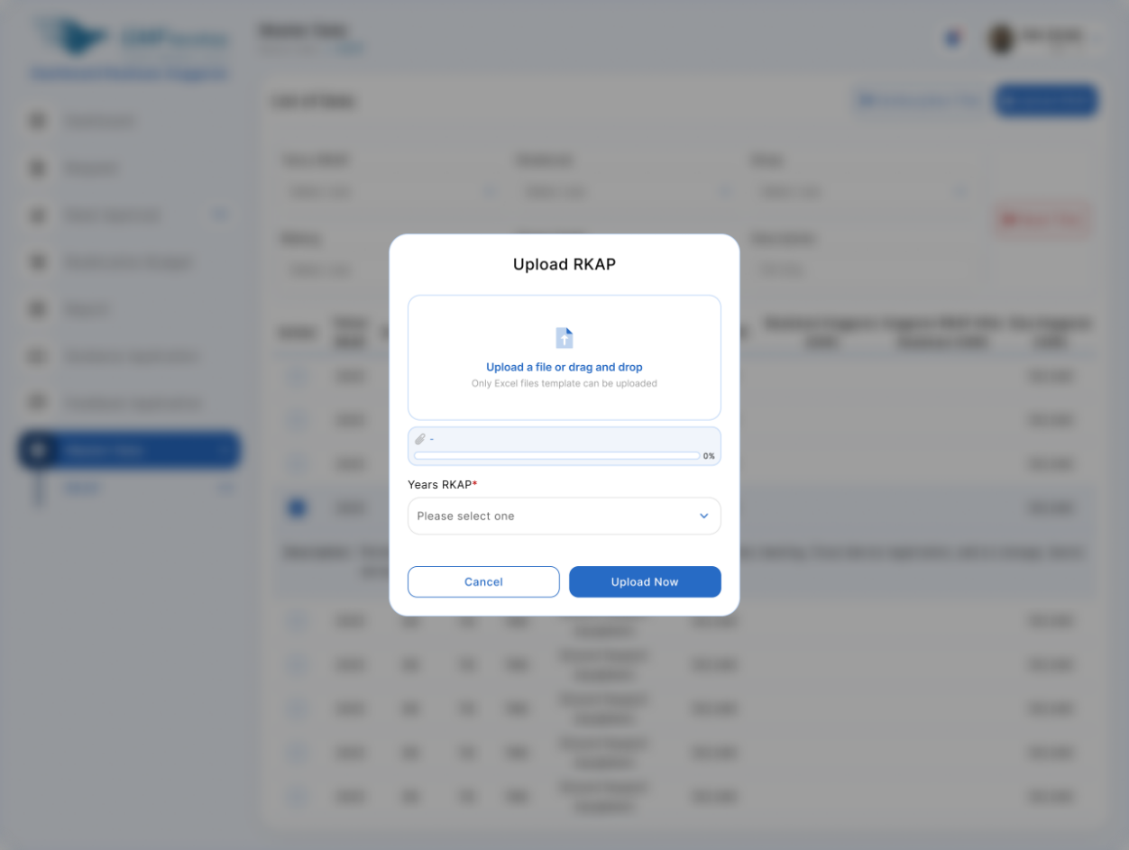

Figure 22Upload RKAP CAPEX

#### Flow Process Upload RKAP CAPEX

#### Request Realization & Reallocation CAPEX

#### Application Mockup Request Realization & Reallocation CAPEXMenu - Dashboard

Figure 23 Dashboard Realizations

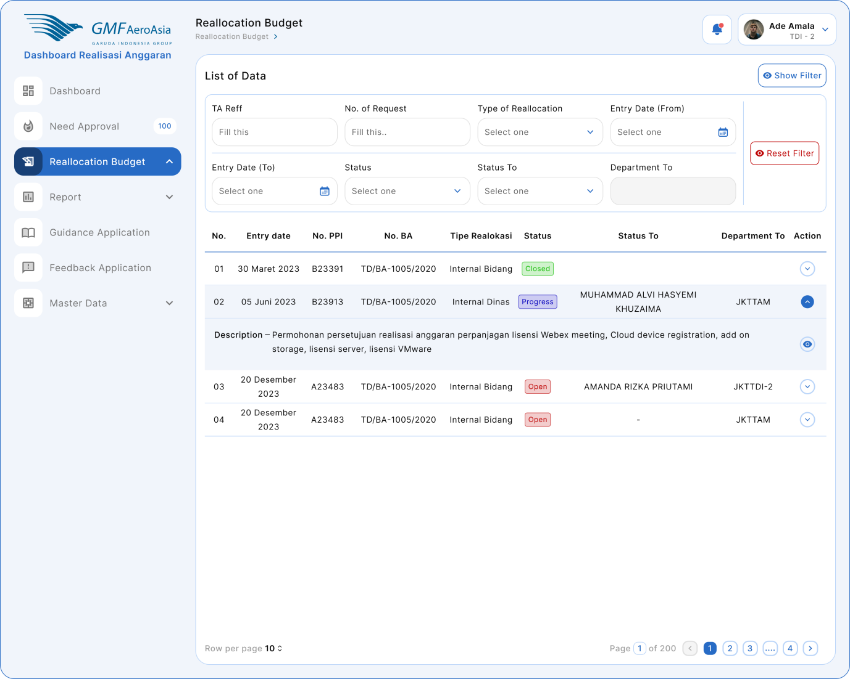

Figure 24 Reallocation Budget

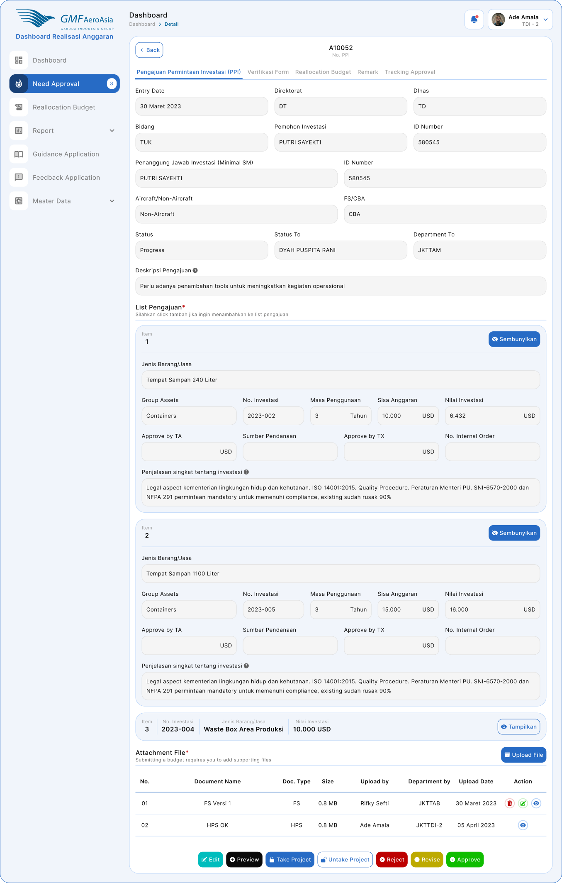

Figure 25 Realization CAPEX

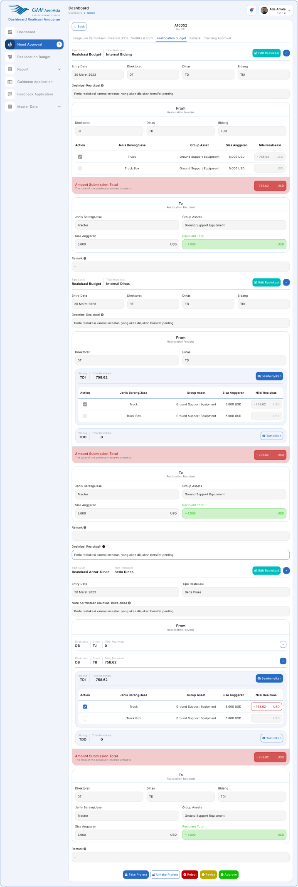

Figure 26 Reallocation CAPEX

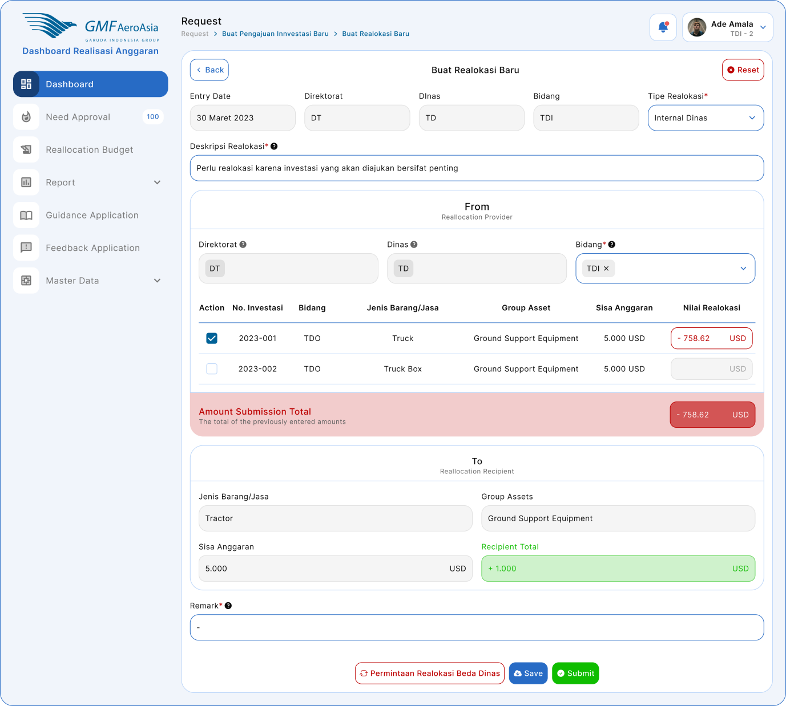

Figure 27 Create Reallocation Internal Dinas CAPEX

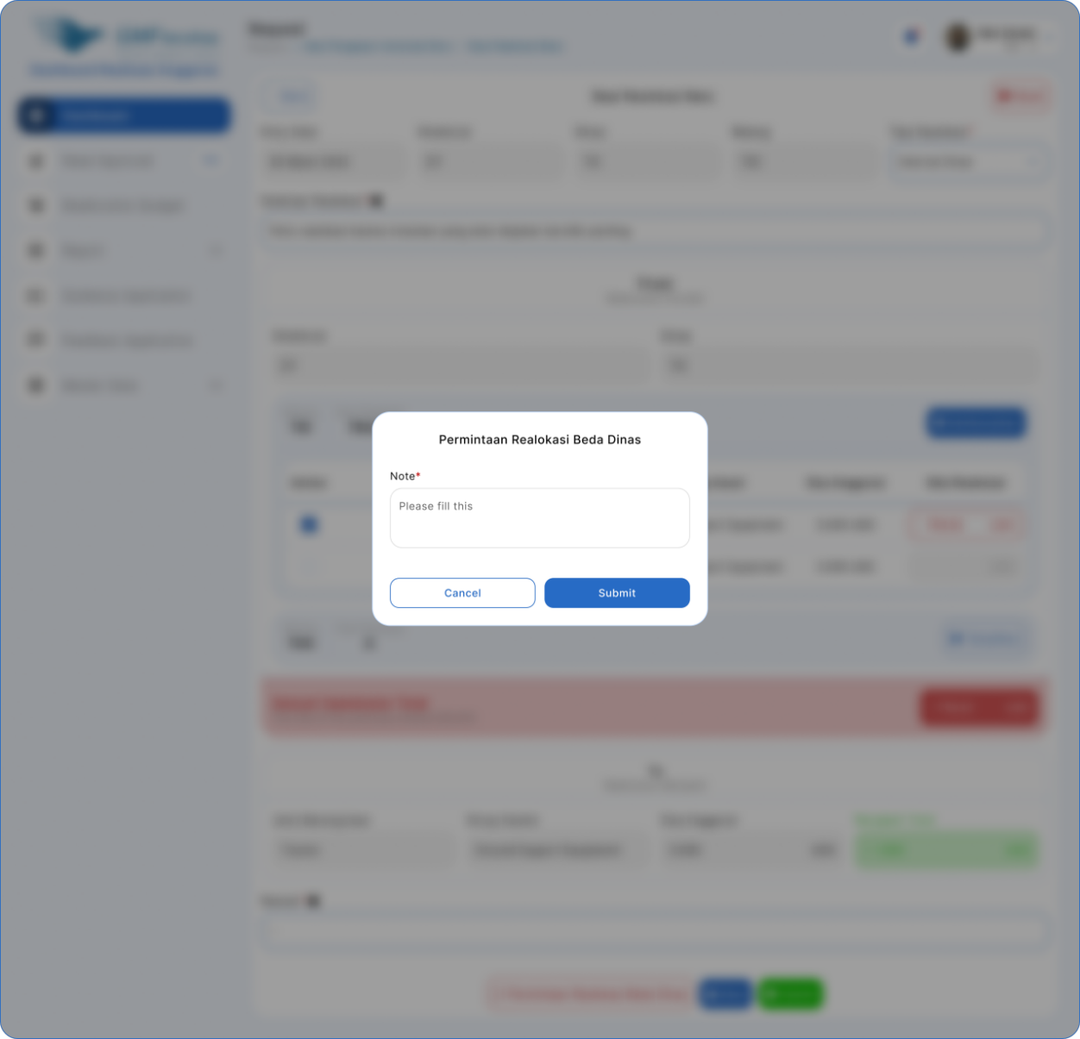

Figure 28 Permintaan Reallocation Beda Dinas CAPEX

#### Flow Process Request Realization & Reallocation CAPEX

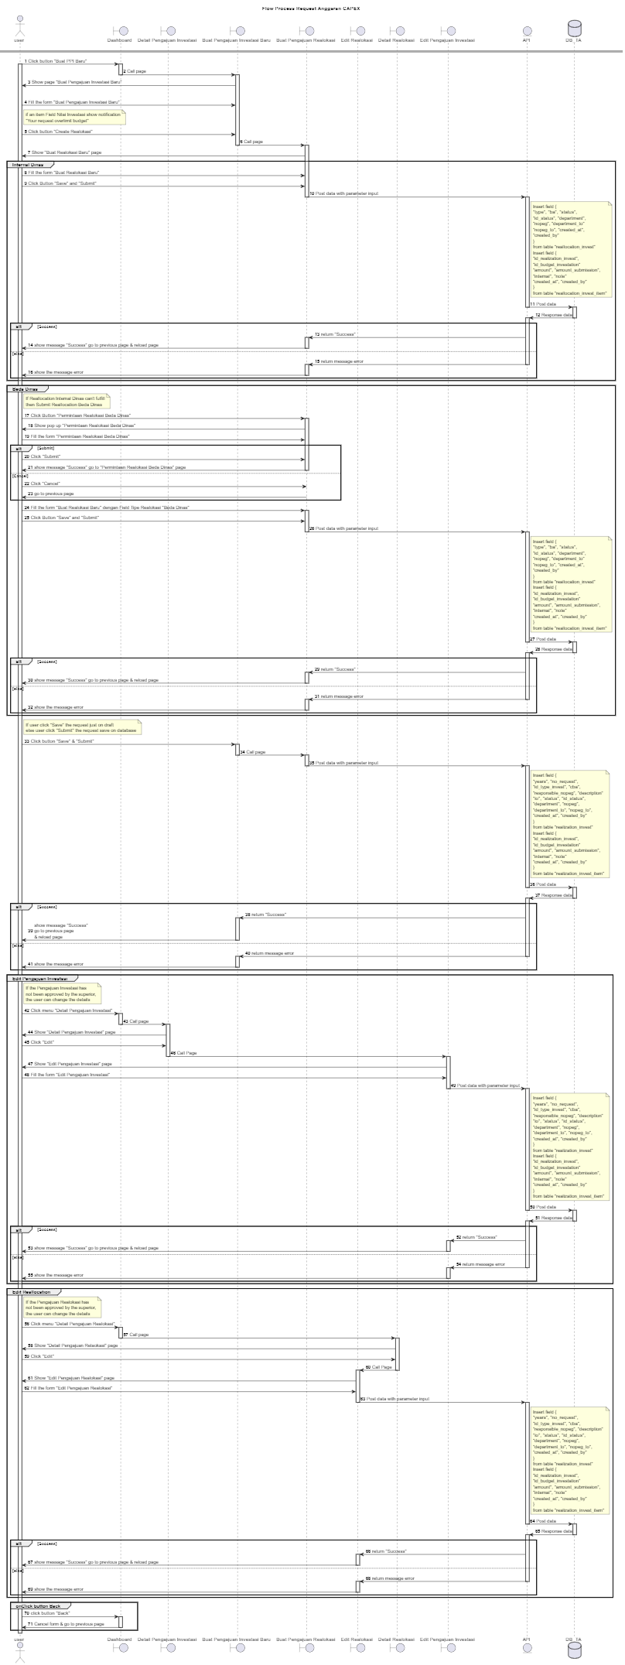

Figure 29 Request Realization & Reallocation CAPEX

#### Approval OPEX

#### Application Mockup Approval OPEX

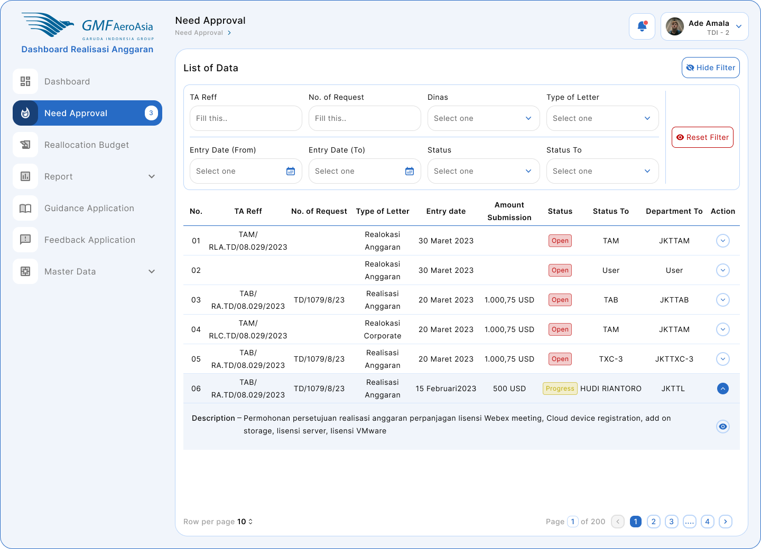

Figure 30 Need Approval OPEX

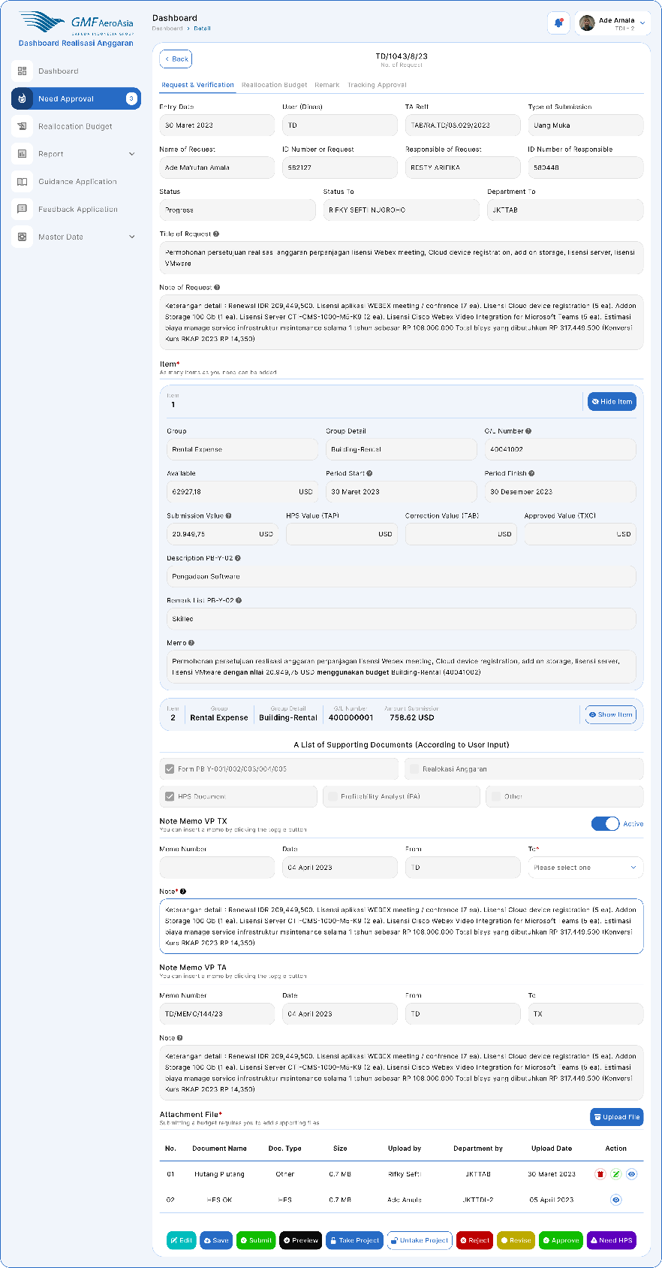

Figure 31Detail Tab - Request & Verification

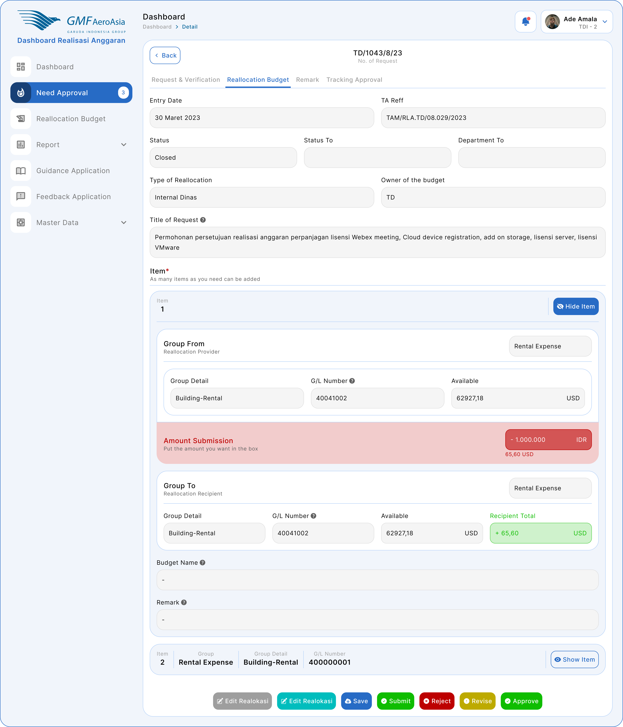

Figure 32 Detail Tab - Reallocation Budget

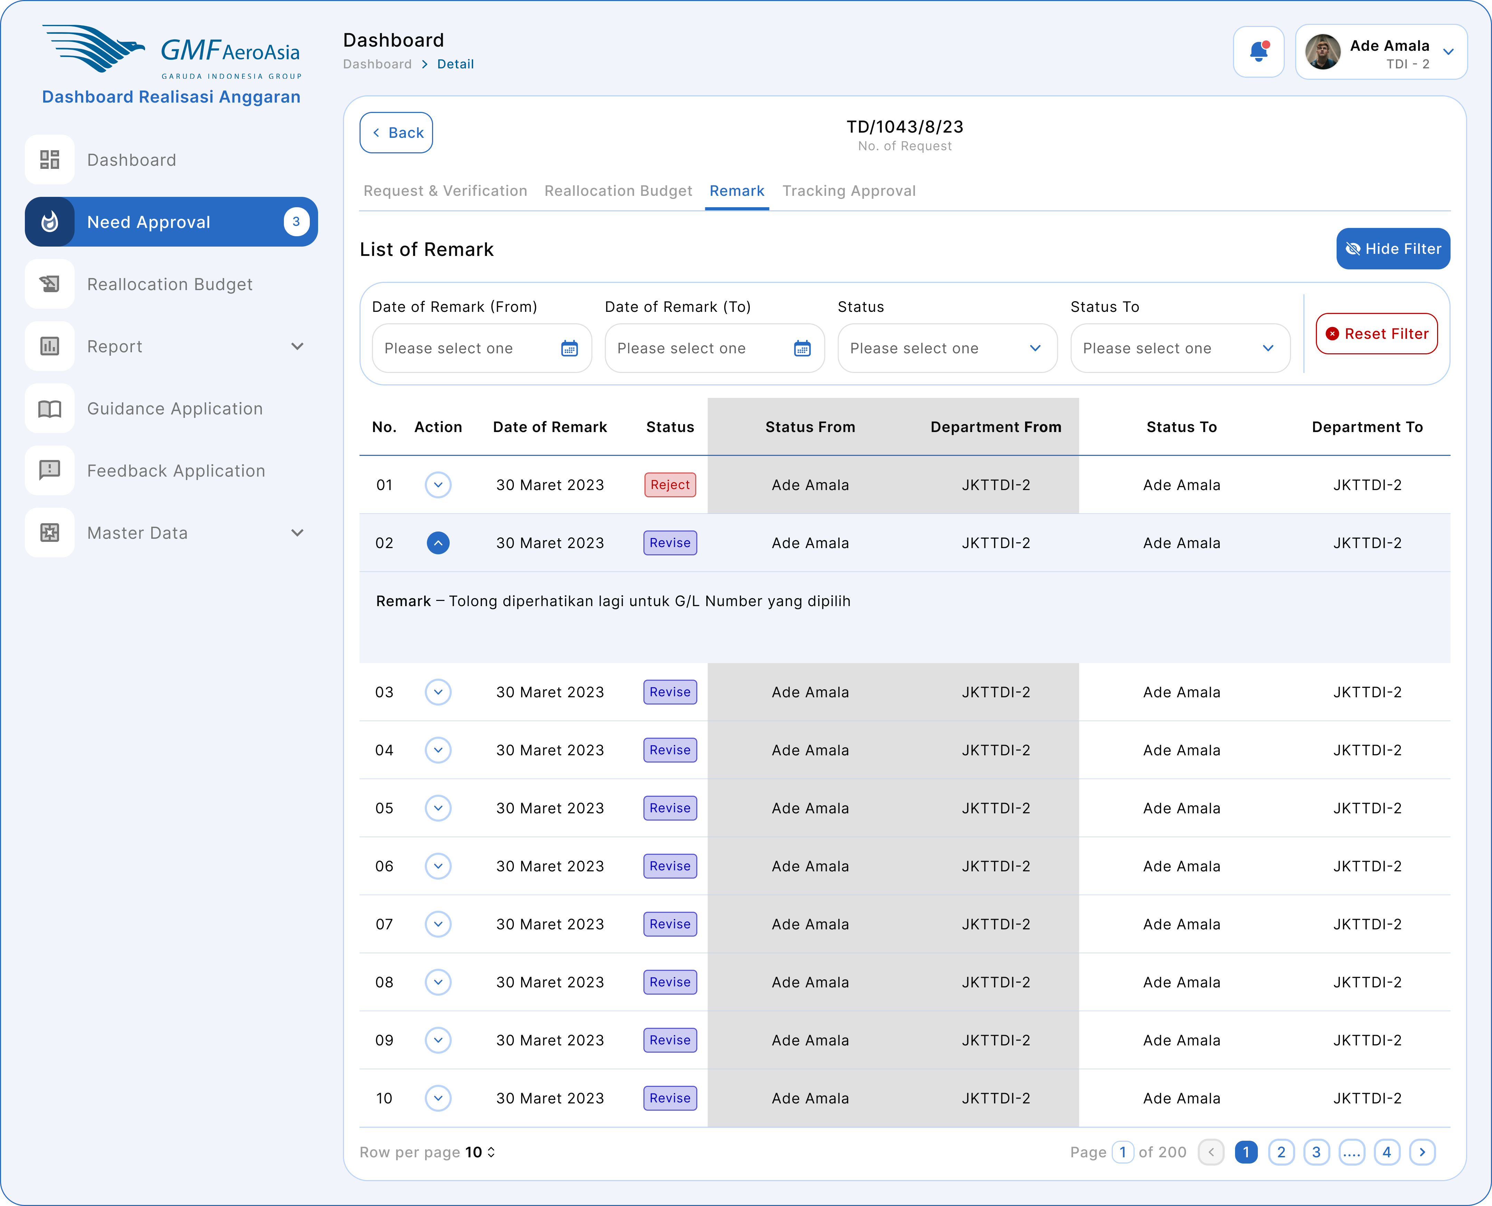

Figure 33 Detail Tab – Remark

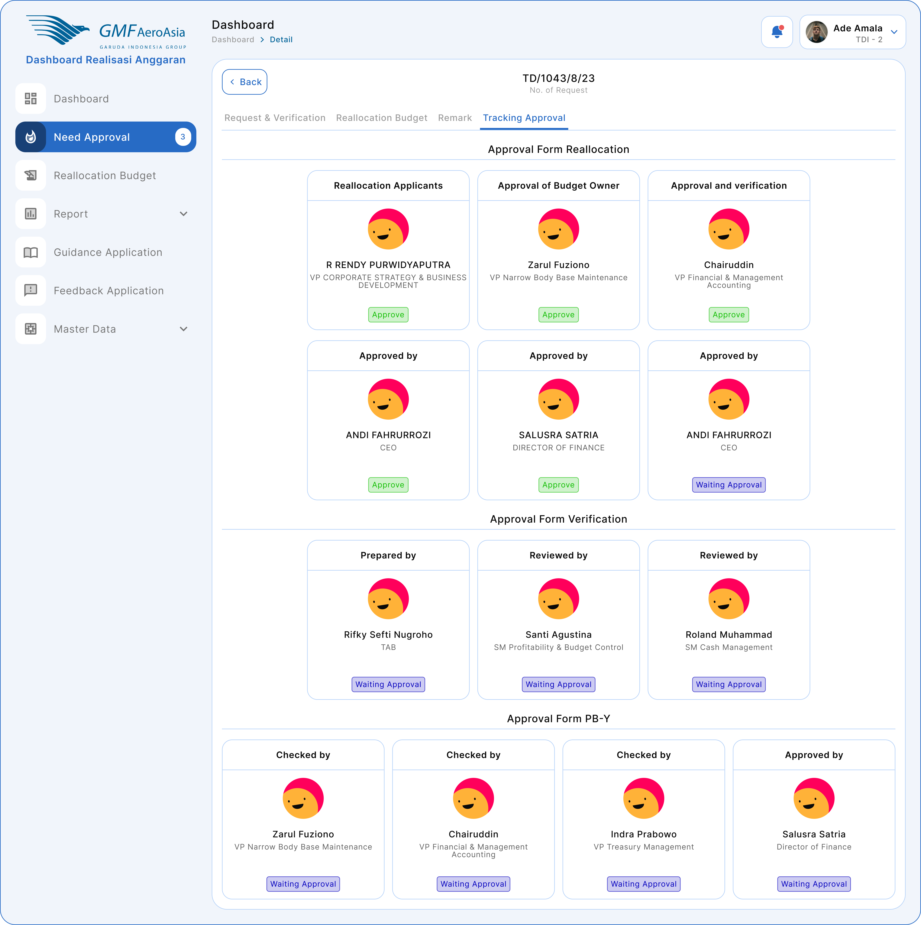

Figure 34 Detail Tab - Tracking Approval

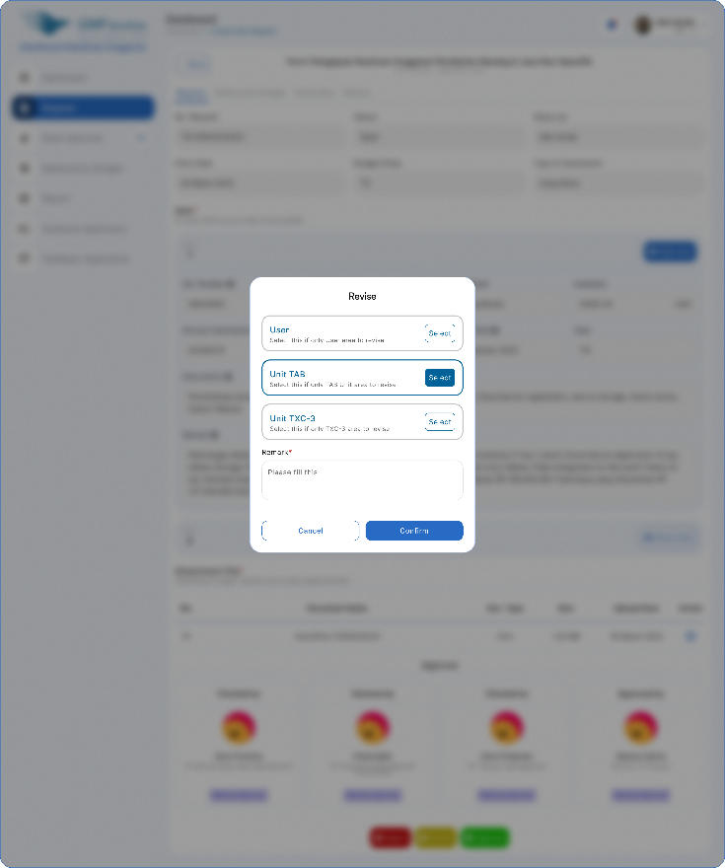

Figure 35 Revise

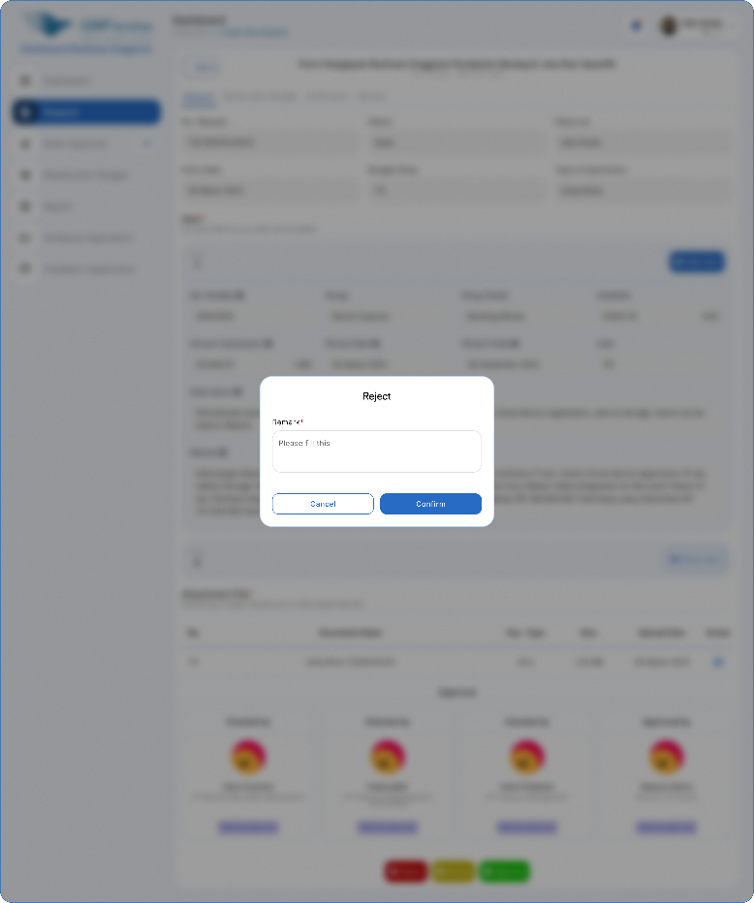

Figure 36 Revise

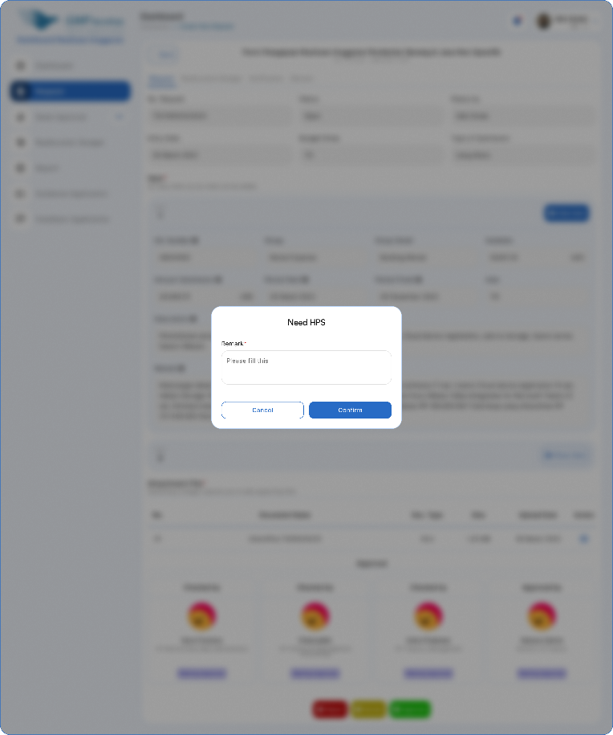

Figure 37 Need HPS

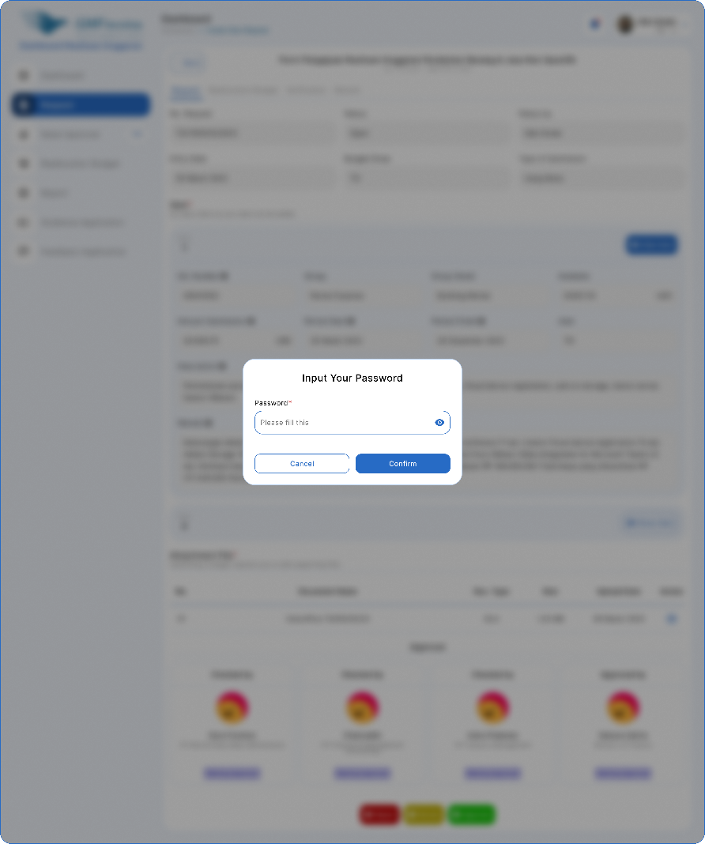

Figure 38 Input Password, ketika mau melakukan aksi approve

#### Flow Process Approval OPEX

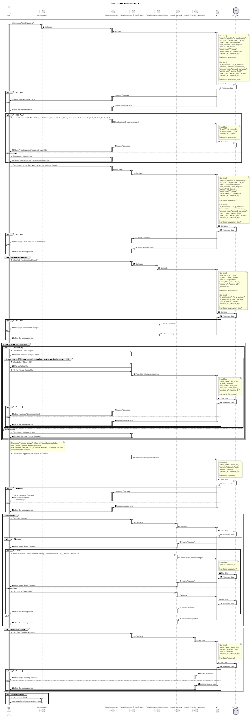

#### Approval CAPEX

#### Application Mockup Approval CAPEX Menu - Need Approval (1)

Figure 39 Need Approval CAPEX

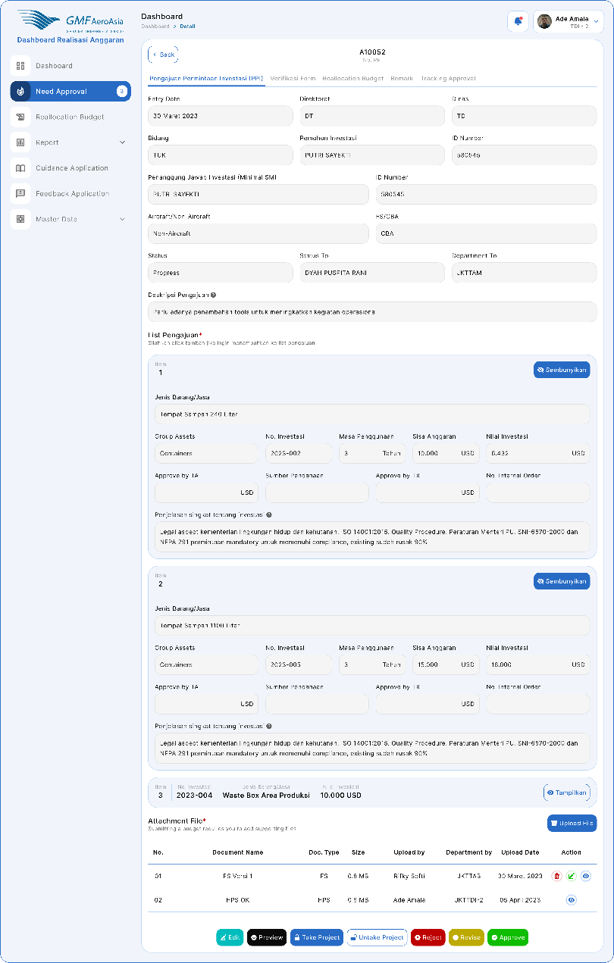

Figure 40 Tab - Pengajuan Permintaan Investasi (PPI)

#### Flow Process Approval CAPEX

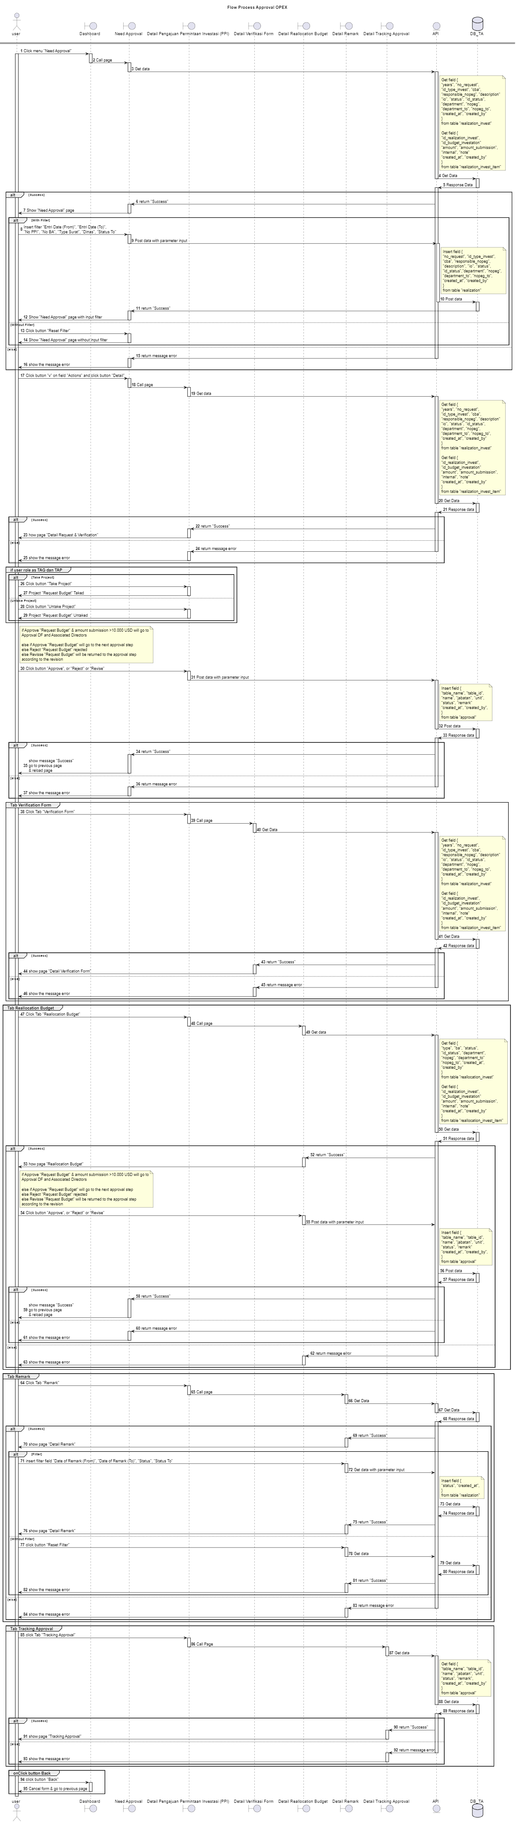

#### Report CAPEX

#### Mockup Application Report CAPEX

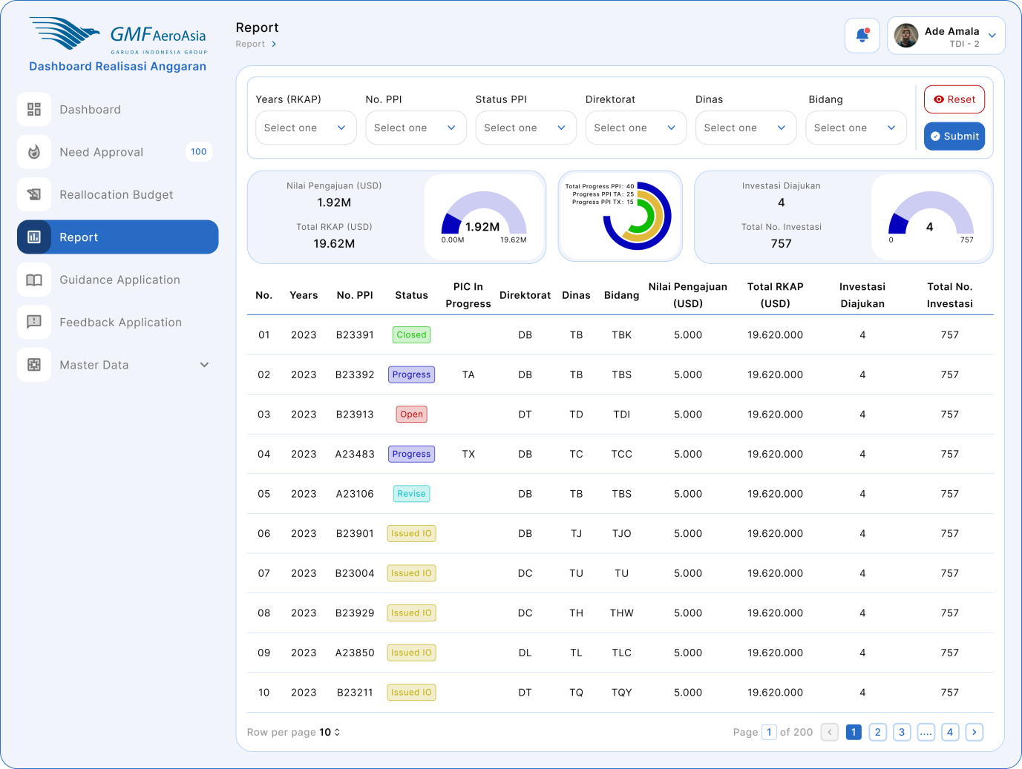

#### Flow Process Report CAPEX

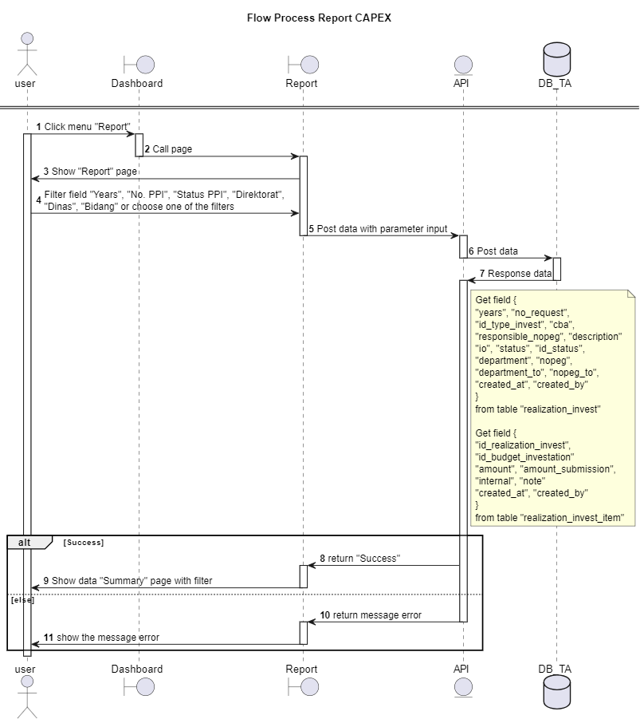

### Desain Database

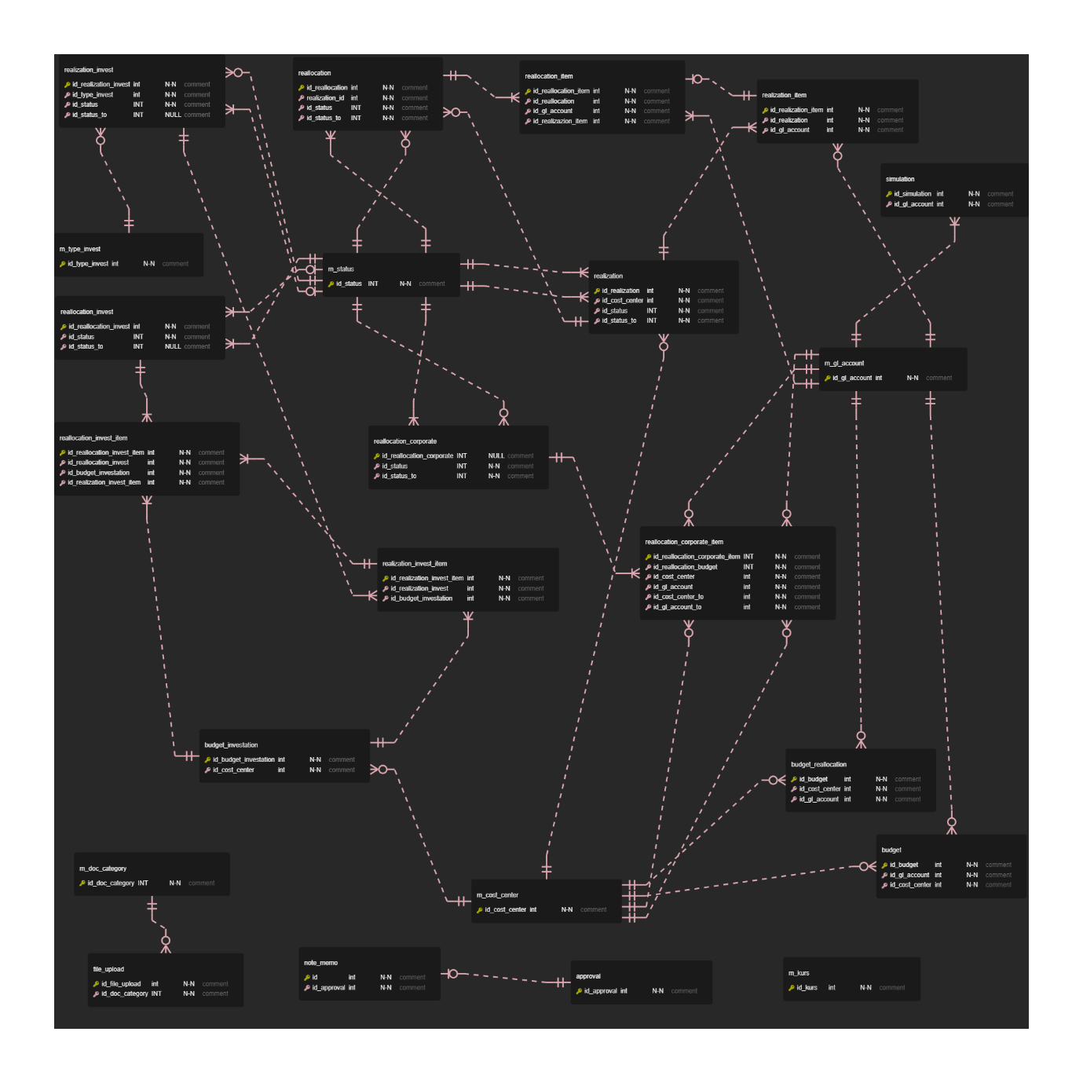

### Role Matrix

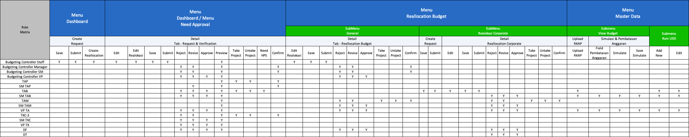

# Lampiran

1. Link Mockup :

<https://www.figma.com/file/uN4rHf3Z3UJUWXSuWtqdyA/Dashboard-Realisasi-%26-Investasi-(OPEX-%26-CAPEX)?type=design&node-id=561-39974&mode=design&t=XYYxKSgG0vB7HWK9-0>